Joacim Rocklöv
Judit Simon

Göteborgs Universitet 2005

Abstract 2
1. Introduction 3
1.1 An introduction to Gibbs free energy 4
1.2 The balance between synthesis and hydrolysis of ATP 5
2 Molecular motors of ATPase 7
2.1 Modeling the chemical reactions 7
2.2 Model of the F₀ motor 9
2.3 The analytical model with fast diffusion 10
3 The numerical model 15
3.1 The numerical model when chemical reactions is as fast as diffusion 15
4 Simplified Implementation 22
5 Discussion 24
6 Appendix 25

Abstract

The enzyme ATPase, which is present in the mitochondria of living cells, produces adenosine triphosphate (ATP) in a process called oxidative phosphorylation. ATP is rich in energy and by cleaving this molecule, thereby generating adenosine diphosphate (ADP) and one free phosphate molecule (Pi), some of this energy is released. The ATP molecules are thus transported from the mitochondria to energy consuming cells where it is used as “fuel” in various chemical reactions. Later, the by-products ADP and P_{i} are transported back to the inner membrane of mitochondria where it is again reoxidized to ATP. The production of ATP is without a doubt one of the most essential processes in nature. Nevertheless, the three-dimensional structure of the complex ATPase is yet to be determined and the exact mechanism of ATP synthesis is still largely unknown.

The synthesis of ATP by the ATPase is a complicated process dependent on an electro chemical proton gradient that is established across the inner mitochondrial membrane. The proton gradient consists of H⁺ ions, which by diffusing into the membrane drives the synthesis of ATP, or if going in the reverse direction drives the hydrolysis of ATP. The ATPase essentially consists of two separate domains, i.e. the F₀ molecular motor and the F₁ molecular motor. The F₀ motor is driven by the energy of H⁺ ions and the F₁ molecular motor in turn uses the mechanical power generated by the F₀ motor to create the conformal changes needed to bind and create the bond between the ADP and P_{i.}

In the present report we have tried to illustrate the energy balance that determines the direction of the molecular motor. The center of attention has been the F₀ motor were we work with a model of the motor in two limiting cases. The first one is solved analytically and the second one is solved numerically by using the Crank-Nicolson method.

1. Introduction
Mitochondria are present in all eukaryotic cells, such as animal and insect cells. They are membrane bound organelles that convert energy, obtained for example from digestion of food, to forms suitable for driving cellular reactions. These cell organelles are enclosed by two separate membranes, the outer and the inner membrane. The energy from oxidation of food molecules, such as glucose, is used to drive pumps, which transfer H+ (protons) from the interior of the mitochondria to the compartment between these two membranes. Consequently, an electro chemical proton gradient is generated across the inner membrane. The chain of processes building up the electro chemical potential is called the electron transport chain or the respiratory chain. This proton gradient, which is charged by the electron transport chain, is subsequently used by the enzyme ATP-synthase, commonly reffered to as ATPase, to produce the energy rich chemical compound adenosine triphosphate (ATP) from adenosine diphosphate and a free phosphate (P_{i}). For example, from every molecule of glucose that is oxidized in the cell, ATPase can produce 30 molecules of ATP. By using the energy liberated when protons flow back through the inner membrane, this enzyme generally catalyzes the conversion of ADP and P_{i} to ATP but it can also go in reverse and hydrolyse ATP resulting in the formation of ADP and P_{i}. The process ADP + P_{i} ↔ ATP is called oxidative phosphorylation.
The flow of protons through the ATPase drives a diffusion process that mechanically can be seen as a molecular motor. This motor has negatively charges sites where the positively charged protons can bind. The sites are situated on a rotor that works like a dipole, which by spanning the entire membrane helps the protons to cross over to the other side. Owing to the high concentration of H+ on the outside of the inner membrane and the low concentration of H+ on the inside of the same membrane, the outer and inner compartments are acidic and basic respectively. Consequently, when the protonated rotor moves from the acidic compartment to the basic side of the membrane, it gets deprotonated. This process works in both directions and is dependent on the strength of the proton gradient. In addition, the ATPase has the ability to bind to ADP and P_{i} on the side facing the interior of the mitochondria. The energy liberated by the diffusion of protons across the membrane is subsequently used by the ATPase to catalyze the generation of a bond between these molecules, i.e. ADP and P_{i}, thereby creating one ATP molecule (see fig. 1).

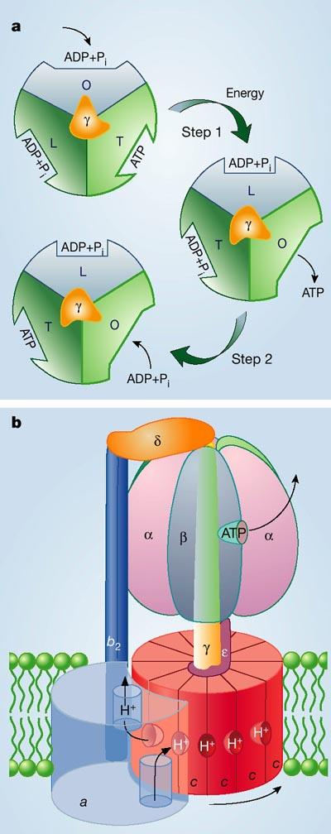

1.1 An introduction to Gibbs free energy
The second law of thermodynamics states that chemical reactions proceed spontaneously in a direction that corresponds to an increase in the disorder of the universe. The entropy is a way to measure this degree of disorder. The change of Gibbs free energy, given by

$$ΔG=ΔH−TΔS$$

where H is the enthalpy, T is the temperature and S is the entropy, is essentially a direct measure of the entropy change of a system. Accordingly, a reaction will proceed in the direction that causes the change in the free energy, ∆G, to be less than zero. However, there are reactions that are spontaneous despite a decrease in entropy. The value of ∆G is also a direct measure of how far the reaction is from equilibrium. The large negative value of G found for ATP hydrolysis in a cell merely reflects the fact that cells keep the ATP hydrolysis reactions as much as 10 orders of magnitude away from equilibrium. If a reaction reaches equilibrium, that is ∆G = 0, it proceeds at equal rates in both directions. For ATP hydrolysis this equilibrium is reached when the vast majority of the ATP has been hydrolyzed, which only occurs in a dead cell. A typical ATP molecule in the human body shuttles in and out of a mitochondrion (in as ADP and out as ATP) for recharging thousands of times per day, keeping the concentration of ATP in a cell about 10 times higher than that of ADP. For a reaction A$→$B the free energy is given by,

Figure 1. Schematic illustration of the ATPase. The ATPase spans the inner membrane of the mitochondria and functions as ATP catalysator. b; This illustration shows how the protons flow from the outside of the membrane to the inside. The diffusion of protons drive the rotation of the c ring and by that the conformal changes of in α and β. a illustrates how the synthesis of ATP is dependent of the of the conformal changes.

$ΔG=ΔG\text{°+}\text{RT}\text{ln}\frac{\left|B\right|}{\left|A\right|}$

where |A| and |B| represent the concentration of A and B respectively and ∆Gº is the standard free energy and R is the gas constant. The chemical equilibrium is reached when

$$\frac{\left|B\right|}{\left|A\right|}=e^{−ΔG°/{\text{RT}}}$$

Due to the efficiency of the ATPase, mitochondria maintains such high concentrations of ATP relative to ADP and $P_{i}$ that the ATP hydrolysis in cells is kept very far from equilibrium and consequently ∆G is very negative. Without this disequilibrium ATP hydrolysis could not be used to direct the reactions of the cell and many biosynthetic reactions would run backwards instead of forward.

1.2 The balance between synthesis and hydrolysis of ATP
The ATPase is a large, multimeric protein, which typically is divided into two separate units. These are the F₀ molecular motor, which is the domain involved in the protons flow across the membrane, and the F₁ molecular motor, which binds ADP and P_{i} and catalyze the generation of ATP. When separated from the proton carrier, however, the F₁ ATpase goes in reverse and catalyses ATP hydrolysis rather than synthesis. Accordingly, the ATPase can either use the energy of ATP hydrolysis to pump protons across the inner mitochondrial membrane or it can utilize the flow of protons down an electrochemical proton gradient to create ATP. It thus acts as a reversible coupling device and its direction depends on the balance between the steepness of the electrochemical proton gradient and the local ∆G for ATP hydrolysis as seen in the previous chapter. It is normally driven to create ATP since the level of ADP in the cells is typically higher than the level of ATP.
The exact number of protons needed to make one ATP molecule is not known with certainty. Let us make things easy and assume it takes 3 protons. Whether ATPase works in its ATP-synthesizing or its ATP-hydrolyzing direction at any instant depends on the exact balance between the favorable free energy change for moving the three protons across the membrane and into the matrix space, ∆G_{3H+} < 0, and the unfavorable free energy change for ATP-synthesis in the matrix, ∆G_{ATPsyntas} > 0. The value of ∆G_{ATPsyntas} depends on the exact concentration of the three reactants ATP, ADP and $P_{i}$ in the mitochondrial matrix space. The value ∆G_{3H+} on the other hand is proportional to the value of the proton motive force across the inner mitochondrial membrane.
If a single proton is moving into the matrix down the electrochemical gradient of 200mV it liberates 4.6kcal/mole of free energy, consequently three protons give a free energy change of ∆G_{3H+} = -13.8 kcal/mole. Thus, if the proton motive force remains constant at 200mV, then the ATPase will synthesize ATP until a ratio of ATP to ADP and P_{i} is reached where ∆G_{ATPsyntas} is just equal to 13.8kcal/mole (∆G_{3H+} + ∆G_{ATPsyntas} = 0 kcal/mole). At this point there will be no further net ATP synthesis or hydrolysis by the ATPase.
Let us assume that a large amount of ATP is suddenly hydrolyzed by energy requiring reactions in the cytosol, causing the ATP:ADP ratio in the matrix to fall. Now the value ∆G_{ATPsyntas} will decrease and the ATPase will begin to synthesize ATP again to restore the original ATP:ADP ratio. Alternatively, if the proton motive force drops suddenly and is then maintained at a constant 160mV, that gives ∆G_{3H+} = -11 kcal/mole, ATPase will start hydrolysing some of the ATP in the matrix until a new balance of ATP to ADP and $P_{i}$ is reached, where ∆G_{ATPsyntas} = 11 kcal/mole.

2 Molecular motors of ATPase
Many molecular mechanisms utilize ATP hydrolysis to generate mechanical forces, and it is frequently stated that the energy is stored in the phosphate covalent bond. Releasing this energy to perform mechanical work can be quite indirect since the protein has a three dimensional structure of amino acids. The F₁ motor of ATPase uses nucleotide hydrolysis to generate a large rotary torque. However, the actual force generating step takes place during the binding of ATP to the catalytic site; the role for the hydrolysis step is to release the hydrolysis products, allowing the cycle to repeat. The F₀ motor of ATPase uses the transmembrane proton gradient to generate a rotary torque. Models of this process show how the chemical reaction of binding a proton onto the site creates an unbalanced electrostatic field that rectifies the Brownian motion of the motor and creates an electrostatic driving torque. Although the proximal energy transduction is a chemical binding event, the motion itself is produced by electrostatic forces and Brownian motion. Thus, a common theme in energy transduction is that chemical reactions power mechanical motion using free energy released during binding events, but the final production of mechanical force may involve a number of intermediate energy transductions.

2.1 Modeling the chemical reactions
When analyzing the process of ATP production in the mitochondria one has to consider not only the mechanics of the molecular motor but also the processes responsible for supplying the molecular motors with energy. In this case the energy sources are the transmembrane protonmotive force and ATP hydrolysis. The latter uses the energy stored in the phosphate covalent bond of the ATP molecule and the former uses the electric and entropic energy arising from a difference in H⁺ concentration across the inner membrane of the mitochondria. We have based our model exclusively on the protonmotive force since hydrolysis is a very complicated process which is still not yet fully understood.

In the first step we have to consider the positively charged ion (the proton) that binds to a negatively charged site on the F₀ motor, that is:

H⁺ + site⁻ ↔ H ∙ site.

The prime focus will however be on the isolated site. Consequently, the neutralization reaction from the site viewpoint is,

site⁻ $\underset{k^{−}}{\overset{k∗}{⇔}}$ site

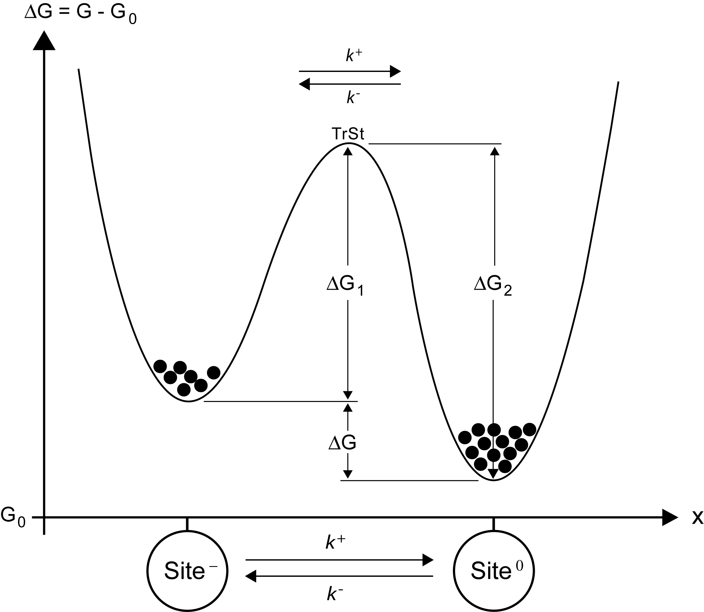
where k* is the forward rate constant, k* = k⁺| H⁺ |. Moreover, the fundamental concept in modeling reactions is to define a reaction coordinate, which is denoted ξ. ξ(t) is the distance between the H⁺ ion and the site⁻. For a fixed proton concentration, the forward chemical reaction proceeds with a rate k*|site|. However, this rate is a statistical average over many hidden events as we are going to see later on. Nevertheless, the advantage with this way of modeling reactions is that it gives a good picture of how to monitor the flux. Similarly, the reverse action takes place when a thermal fluctuation confers enough kinetic energy on the proton to overcome the electrostatic attraction. In our case the reverse action takes place when ATP is hydrolyzed and the motor goes in reverse. To be able to see the connection between the forward and the backward reactions it helps to have a formula for the net flux, J_{ξ}, over the barrier,

J_{ξ} = k*|site⁻| - k⁻ |site|.

After a long time the net flux over the barrier will vanish, J_{ξ} = 0, so that the population of neutral and charged sites will distribute themselves in a fixed ratio, which we denote by keq = |site|/|site⁻| = k*/ k⁻. If the transition state (TrSt in Fig. 2) is high, which it is in this case, then keq is apportioned according to the Boltzmann distribution: k_{eq} = exp(∆G/k_{B}T). As already mentioned, the value of ∆G determines how far the reaction goes but says noting about the rate of the reaction. We know from thermo dynamics that, ∆G = ∆H - T∆S. the enthalpy term ∆H is due to the electro static attraction between the proton and the charged site. The entropic term T∆S incorporates all the effects that influence the diffusion of the proton to the site and its escape from it. Thus, the equilibrium, ∆G = 0, is a compromise between energy, ∆H, and randomness, T∆S. All of these parameters can be considered as hidden coordinates, which are very hard to compute explicitly but can be easier to measure phenomenologically simply by using the rate constants to summarize their statistical behavior. Therefore we can treat the reactions as a Markov chain,
Figure 2. The picture shows the free energy diagram for sites that is deprotonated respectively protonated and its corresponding Markov Model. The equilibrium distribution between the wells depends only on ∆G.

$\frac{d|\text{site}|}{\text{dt}}=\frac{d|{\text{site}}^{−}|}{\text{dt}}$ = net flow over the energy barrier = (0)

= J_{ξ} = k*|site⁻| - k ⁻ |site|, or in vector form

$\frac{d}{\text{dt}}$P = J_{ξ} = K P, P = $\left(\begin{matrix}p_{−} \\ p_{0}\end{matrix}\right)$, K = $\left(\begin{matrix}k∗ & −k^{−} \\ −k∗ & k^{−}\end{matrix}\right)$.

Here p₋ and p₀ are the probabilities to have a negatively charged or neutral site.

2.2 Model of the F₀ motor
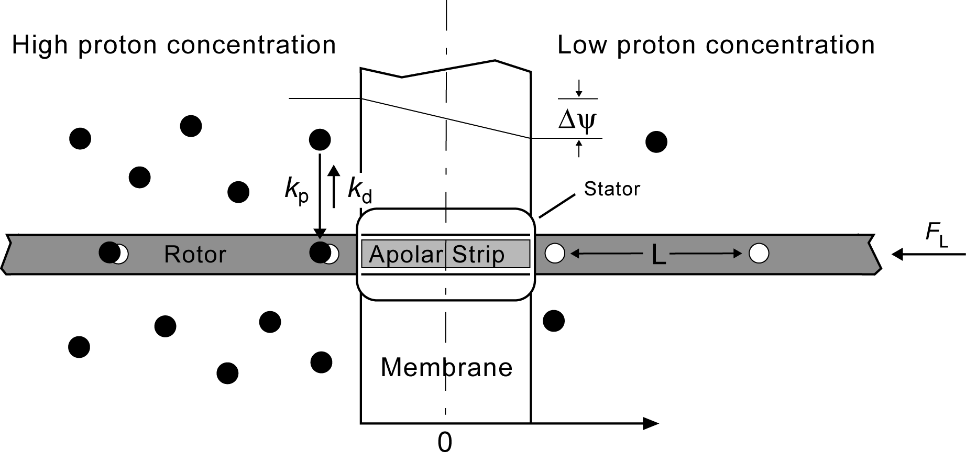
The F₀ motor is sketched schematically in figure 3. It consists of two reservoirs separated by an ion impermeable membrane. The reservoir on the left is acidic, that means it has a high proton concentration c^{acid}, and the one to the right is basic, which means it got a low proton concentration c^{base}.
Figure 3. Simplified model illustrating the principle of the F₀ motor.

The motor itself consist of a rotor carrying negatively charged sites a distance L apart that can be protonated and unprotonated. In addition, there is a stator consisting of a hydrophobic barrier that is penetrated by an apolar strip that can allow a protonated site to pass through the membrane, but will block the passage of an unportonaded site.
The height of the energy barrier blocking passage of a charge between two media with different dielectric constants, ε1 and ε2 respectively, is ∆G ≈ 200((1/ ε1) – (1/ ε2)) ≈ 45k_{B}T. This energy penalty arises from the necessity of stripping hydrogen bonded water molecules from the rotor sites.
Rotor sites on the acidic side of the membrane are frequently protonated, and in this state the rotor function as a nearly neutral dipole that can diffuse to the right, allowing the protonated site to pass through the membrane stator interface to the basic reservoir. When the proton reaches the basic side it quickly dissociates from the rotor site. In its charged state, the rotor site cannot diffuse backwards across the interface: Its diffusion is ratcheted. Consequently, a rotor site can exist in two states: unprotonated and protonated. To simplify the model we focus on the site immediately adjacent to the membrane on the acidic side. In its unprotonated state the site adjacent to the membrane is immobilized. It can neither pass into the stator, nor can it diffuse to the left since the next rotor site on the basic side of the membrane is almost always deprotonated. Thus, the progress of the model can be pictured as a sequence of transitions between two potentials. When deprotonated the rotor becomes immobilized in potential φd, and when protonated, it can move in potential φ_{p}. The effect of the load force F_{L} is to tilt the potential upwards, so the motion in potential φ_{p} is “uphill”. The total potential when protonated can be written as φ_{p}(x) - F_{L}(x).

It is possible to construct two different models of this motor, or more precise two different limiting cases. First we choose to treat the model analytically. In this case the diffusion is much faster than the chemical reaction rates. In the second, numerically treated, model the diffusion time scale is comparable to the reaction rates in the basic reservoir.

2.3 The analytical model with fast diffusion
We by start by define the probability of the deprotonated and protonated states as p_{d}(t) and p_{p}(x,t) respectively with dimension (1/nm). x, 0 ≤ x ≤ L, is the distance of the protonated site from the interface between the acidic reservoir and the membrane. Then we can express the derived probabilities as the net flux,

$\frac{{\text{dp}}_{d}}{\text{dt}}$ = net deprotonated spatial flux + net reaction flux = J_{xd} + J_{ξ} , (1)

$\frac{∂p_{p}}{∂t}$ = net protonated spatial flux – net reaction flux = J_{xp} - J_{ξ},, (2)

Where,
J_{xd} = 0,
J_{xp} = $D\left(\frac{∂}{∂x}\frac{∂p_{p}}{∂x}−\frac{F_{I}−F_{L}}{k_{B}T}P_{p}\right),J_{\text{xp}}(0)=J_{\text{xp}}(L)=0,$
J_{ξ} = deprotonation at acidic reservoir + deprotonation at basic reservoir –
net protonation at both reservoirs = k_{d} p_{p}(0) + k_{d} p_{p}(L) - $\overline{k_{p}}p_{d}$.

The net protonation rates at both reservoirs is $\overline{k_{p}}$= k_{p}c^{acid} + k_{p}c^{base}. $\overline{k_{p}}$ with the dimension (1/s). k_{d} has the dimension (nm/s). We have to assume that the protonation rates are equal at both reservoirs. First we nondimensionalize the model equation using the rescaled coordinate (x/L) → x, and the rescaled time (k_{d}t/L) → t, and the following dimensionless parameters:

- Ratio of reaction to diffuse time scale: Λ = D/k_{d}L.
- Net work done in moving a the rotor a distance L: w = (F_{I} – F_{L})L/k_{B}T.
- Equilibrium constant: κ = $\overline{k_{p}}$L/k_{d.}

Here F_{I} = eψ/L is the electric driving force, which is assumed to be constant. Substituting these variables and parameters into equations (1) and (2) gives,

$\frac{{\text{dp}}_{d}}{\text{dt}}$ = - κp_{d} + p_{p}(0) + p_{p}(1), (3)

$\frac{∂p_{p}}{∂t}$ = κp_{d} - p_{p}(0) - p_{p}(1) + Λ$\frac{∂}{∂x}\left(\frac{∂p_{p}}{∂x}−{\text{wp}}_{p}\right)$, (4)

where x,t are now the nondimensional coordinate and time.
In many situations it turns out that diffusion is much faster than the chemical reaction rates: Λ >> 1. This imply that the time between dissociation events is much longer than the time to diffuse a distance L, so the process is limited by the speed of the reactions, not by the diffusion of the rotor. In other words, the diffusive motion of the rotor is so fast that it achieved thermodynamic equilibrium, hence, its displacement can be described by a Boltzmann distribution. In this case we can express the probability distribution as p_{p}(x,t) = p_{p}(t)P(x), where p_{p}(t) is the probability of the site being in the protonated state and P(x) is the equilibrium spatial probability density describing the rotors position relative to the stator.
We can obtain the steady state Boltzmann distribution P(x) from (4). First we divide through by Λ and take advantage of the fact that Λ>>1: All terms but the last are rendered negligible, so that the distribution of rotor positions in the protonated state potential well φp(0 ≤ x ≤ 1) is given by,

$\frac{\text{dP}}{\text{dx}}−\text{wp}=0$.

Since the solution should be a probability density function it must be normalized to 1,

P(x) = $\left(\frac{w}{e^{w}−1}\right)e^{\text{wx}}$, 0 ≤ x ≤ 1,

where the parenthesis represents the normalization factor. Thus the rates of protonation at time t are p_{p}(0,t) = p_{p}(t)P(0) and p_{p}(1,t) = p_{p}(t)P(1). We substitute this into (3) and by using the conservation of probability, p_{d}(t) + p_{p}(t) = 1, we reduce the problem to a two step markov chain described by:

$\frac{{\text{dp}}_{d}}{\text{dt}}=−\frac{{\text{dp}}_{p}}{\text{dt}}$= - κp_{d} + ( P₊ + P₋ )p_{p} ,

where P₊ (w) = w/(1 - ew), P-(w) = w/(ew – 1). Therefore, the stationary probabilities are obtained directly by setting the time derivatives equal to zero and solving for p_{p}:

p_{d}(w, κ) = $\frac{P_{+}+P_{−}}{κ+P_{+}+P_{−}}$, p_{p}(w, κ) = $\frac{κ}{κ+P_{+}+P_{−}}$,

or in the dimensional variables:

p_{d}(w, κ) = $\frac{k_{d}P_{+}+k_{d}P_{−}}{k_{p}(c^{\text{acid}}+c^{\text{base}})L+k_{d}P_{+}+k_{d}P_{−}}$, (5)

p_{p}(w, κ) = $\frac{k_{p}(c^{\text{acid}}+c^{\text{base}})L}{k_{p}(c^{\text{acid}}+c^{\text{base}})L+k_{d}P_{+}+k_{d}P_{−}}$. (6)

By using the following arguments we can calculate the average velocity of the motor. The motor effectively moves to the right, either from the protonated state when the proton is released to the basic reservoir with the effective rate k_{d}P₊ , or from the deprotonated state when the protonation takes place at the acidic reservoir with the effective rate k_{p}c^{acid}L. The corresponding effective rate of movement to the right is the sum of the corresponding rates weighted by the respective state probabilities:

$\left\langle V_{r}\right\rangle$ = k_{p}c^{acid}Lp_{d} + k_{d}P₊ p_{p.}

Similarly, the rotor effectively moves to the left, either from the protonated state when the proton is released to the acidic reservoir with the effective rate k_{d}P₋ , or from the de-protonated state when the protonation takes place at the basic reservoir with the effective rate k_{p}c^{base}L. The corresponding effective rate of movement to the left is the sum of the corresponding rates weighted by the respective state probabilities:

$\left\langle V_{l}\right\rangle$ = k_{p}c^{base}Lp_{d} + k_{d}P₋ p_{p.}

The net average velocity $\left\langle V\right\rangle$ = $\left\langle V_{r}\right\rangle$ - $\left\langle V_{l}\right\rangle$, can be obtained by using the expressions for the state probabilities (5) and (6),

$\left\langle V\right\rangle$(F_{L}) = $\frac{k_{p}k_{d}\text{Lw}(c^{\text{acid}}e^{w}−c^{\text{base}})}{(e^{w}−1)k_{p}L(c^{\text{acid}}+c^{\text{base}})+k_{d}w(e^{w}+1)}$, w= $\frac{(F_{I}−F_{L})L}{k_{B}T}$. (7)

When there is no load F_{L} = 0, no membrane potential F_{I} = 0 and no proton gradient $c^{\text{acid}}=c^{\text{base}}$ , then the velocity vanishes as it should. The stall force F_{s} is reached when the load force brings the motor to a halt, $c^{\text{acid}}e^{w}−c^{\text{base}}$ = 0:

F_{s} = F_{I} + $\frac{k_{B}T}{L}\text{ln}\left[\frac{c^{\text{acid}}}{c^{\text{base}}}\right]$, (8)

And since the electrical driving force satisfies F_{I} = e∆ψ/L, (8) can be written as an equilibrium thermodynamic relation in terms of the energy:

F_{s} ∙L = e ∆ψ – 2.3k_{B}T ∆pH.

This equation tells us that the reversible work performed to move a rotor site across the membrane is equal to the work done by the electrical field, plus the entropic work done by the Brownian ratchet. Revesible in this case means the velocity is near stall.

3 The numerical model

3.1 The numerical model when chemical reactions is as fast as diffusion
Now we are going to model a different case where the diffusion time scale is comparable to the reaction rates in the basic reservoir. This case forces us to change the mathematical formulation of the model. We make the assumption that the proton concentration in the acidic reservoir is so high that the binding sites are always protonated. Now we define the right boundary of the membrane as the origin, and the distance between the membrane and the binding site nearest the membrane in the basic reservoir x is always between 0 and L. The chemical state of the rotor is determined by the state of all the binding sites in the acidic reservoir. In general, if there are N binding sites on this side, the total number of chemical states is 2^{N}. However, for now we focus on the binding site nearest the membrane. In this case there are just two states: “off” if the site is unprotonated and “on” if the site is protonated. These equations are given by,

$\frac{∂}{∂t}\left(\begin{matrix}p_{1} \\ p_{2}\end{matrix}\right)$= net flow in space + net flow along the reaction coordinates =
$$−\left(\begin{matrix}(∂/∂x_{1})J_{x1} \\ (∂/∂x_{2})J_{x2}\end{matrix}\right)+\left(\begin{matrix}J_{ξ1} \\ J_{ξ2}\end{matrix}\right)=−D\left(\frac{−(∂/∂x_{1})\left[p_{1}∂({φ_{1}}/{k_{B}}T)/∂x_{1}+(∂{p_{1}}/∂x_{1})\right]}{−(∂/∂x_{2})\left[p_{2}∂({φ_{2}}/{k_{B}}T)/∂x_{2}+(∂{p_{2}}/∂x_{2})\right]}\right)+\left(\begin{matrix}k^{−}p_{2}−k∗p_{1} \\ k∗p_{1}−k^{−}p_{2}\end{matrix}\right)$$

and the mechanochemistry od the motor is described by the following set of coupled diffusion equations:,

$\frac{∂p_{d}}{∂t}=D\frac{∂}{∂x}\left(\frac{F_{L}−F_{I}}{k_{B}T}p_{d}+\frac{∂p_{d}}{∂x}\right)−{\overline{k}}_{p}p_{d}+k_{d}p_{p}$, (9)

$\frac{∂p_{p}}{∂t}=D\frac{∂}{∂x}\left(\frac{F_{L}−F_{I}}{k_{B}T}p_{p}+\frac{∂p_{p}}{∂x}\right)+{\overline{k}}_{p}p_{d}−k_{d}p_{p}$, (10)

Where p_{p}(x, t) and p_{d}(x, t) (1/nm) are the probability densities for being at position x and in the protonated and deprotonated states, respectively, at time t. The proton association and dissociation rates in the basic reservoir are k_{p} (1/s) and k_{d} (1/s), respectively.
We can non-dimensionalize these equations using the rescaled coordinate (x/L) → x, the rescaled time kdt → t, and the dimensionless parameters Λ= (D/k_{d}L²), w = (F_{I} - F_{L})L/k_{B}T, and κ = k_{p}/k_{d}. The nondimensional equations have the form

$\frac{∂p_{d}}{∂t}=Λ\frac{∂}{∂x}\left({\text{wp}}_{d}+\frac{∂p_{d}}{∂x}\right)−{κp}_{d}+p_{p},$ (11)

$\frac{∂p_{p}}{∂t}=Λ\frac{∂}{∂x}\left({\text{wp}}_{p}+\frac{∂p_{p}}{∂x}\right)+{κp}_{d}−p_{p}\text{.}$ (12)

Equations (11) and (12) are second order partial differential equations. This means that four boundary conditions are required in order to have a mathematically complete description of the problem.
One boundary condition is that x = 0 is reflecting:
${\left[{\text{wp}}_{d}+\frac{∂p_{d}}{∂x}\right]}_{x=0}=0$, (13)

This takes into account that an unprotonated site cannot pass back through the membrane. The remaining three boundary conditions require knowing the state of all the binding sites in the basic reservoir, which would be necessitate solving a large number of coupled diffusion equations, one for each possible chemical state of the rotor. However, to make it as simple as possible we construct a reflecting boundary condition at x = 1, where x is measured in units of L and the rotor is in the protonated state. That is,

${\left[{\text{wp}}_{p}+\frac{∂p_{d}}{∂x}\right]}_{x=1}=0$. (14)

if the proton dissociation rate is fast and the proton concentration is low in the basic reservoir. We don’t expect this artificial boundary to have much of an effect, since in this limit the probability of the first site being occupied when x = 1 is very small, so that this boundary condition is rarely encountered.
When a unprotonated site moves to the right of x = 1, it brings a protonated site out of the membrane channel and into the region 0 < x < 1. This protonated site becomes the new site that we follow. The state of the motor goes from unprotonated to protonated, and the coordinatae of the motor goes from x = 1 to x = 0. Conversely, when a protonated site moves into the the membrane, it brings an unprotonated site into the region 0 < x < 1. This unprotonated site becomes the new site we follow. The state and the coordinate of the motor change accordingly. These considerations are illustrated in fig page 371. The boundary condition that model this situation are:
${\left({\text{wp}}_{d}+\frac{∂p_{d}}{∂x}\right)}_{x=1}={\left({\text{wp}}_{p}+\frac{∂p_{p}}{∂x}\right)}_{x=0}$, p_{d}(1, t) =p_{p}(0, t), (15)

Which is the mathematical statement of the fact that the rotor in the off state at x = 1 is equivalent to the rotor in the on state at x = 0. Therefore, to implement these boundary conditions numerically, we make use of a periodic boundary condition. But before we do that we have to introduce a numerical algorithm that preserves detailed balance. Detailed balance is a constraint placed on c_{eq}(x) to ensure that systems in equilibrium do not experience a net drift. That is, when a system is in equilibrium, J_{x} is required to be identically zero. Detailed balance ensures that the equilibrium density has a Boltzmann distribution.
To obtain an algorithm that has detailed balance built in, we convert the problem into a Markov chain and to do that we have to discretize space. Let x_{n} = (n -1/2)∆x for n = 0, $±$1, $±$2, $±$3,…. be discrete sites on which the protein can reside. Site x_{n} is represented by the interval $\left[x_{n}−{Δx}/2,x_{n}+{Δx}/2\right]$, that is when the proton is in that interval we treat it as being at site x_{n}. If the proton is at site x_{n} then it can jump to either x_{n+1} or x_{n-1}. The notation we have adopted is that F_{n+1/2} is the rate at which the proton jumps from x_{n} to x_{n+1}. Similarly, B_{n+1/2} is the rate at which the proton jumps from x_{n+1} to x_{n}. For small enough Δx, we have p_{n}(t) ≈ p(x, t)Δx, where p_{n}(t) is the probability that the proton is at x_{n} at time t. The governing equation for p_{n}(t) is

$\frac{{\text{dp}}_{n}}{\text{dt}}$= -(B_{n-1/2} + F_{n+1/2})p_{n} + F_{n-1/2}p_{n-1} + B_{n+1/2}p_{n+1} =
(F_{n-1/2}p_{n-1} – B_{n-1/2}p_{n}) – (F_{n+1/2}p_{n} – B_{n+1/2}p_{n+1}) = J_{n-1/2} – J_{n+1/2}, (16)
Where J_{n+1/2} is the net flux between the points x_{n} and x_{n+1}.
The numercal scheme must approximate the actual dynamics of the protons. The following jump rates preserves the mean drift motion as well as detailed balance:
$F_{n+1/2}=\frac{D}{{\left(Δx\right)}^{2}}\frac{{{Δϕ}_{n+1/2}}/{k_{B}}T}{\text{exp}({{Δϕ}_{n+1/2}}/{k_{B}}T)−1}$, (17)
$B_{n+1/2}=\frac{D}{{\left(Δx\right)}^{2}}\frac{{−{Δϕ}_{n+1/2}}/{k_{B}}T}{\text{exp}({{Δϕ}_{n+1/2}}/{k_{B}}T)−1}$, (18)
Where ${Δϕ}_{n+1/2}=ϕ(x_{n+1})−ϕ(x_{n})$.
Periodic boundary conditions require that p_{M+1}(t) = p₁(t) and p₀(t) = p_{M}(t). Using these two equalities in (16) for p₁ and p_{M} produces

$\frac{{\text{dp}}_{1}}{\text{dt}}$= - (B1/2 + F3/2)p1 +FM+1/2pM +B3/2p2, (19)

$\frac{{\text{dp}}_{M}}{\text{dt}}$= - (BM-1/2 + FM+1/2)pM +FM-1/2pM-1 +B1/2p1, (20)
Where we made use of the fact that B_{1/2} = B_{M+1/2} and F_{1/2} = F_{M+1/2}.
Note that there are two mechanisms for changing the chemical state of the rotor, movement of the rotor and chemical kinetics.
We are now in position to use the numerical algorithm above to approximate (11) – (15). The interval (0, 1) is divided into M segments. For each of the M grid points there are two possible states of the rotor, off and on. Therefore, there are 2M possible states in the discrete approximation of the process. Let the first M states correspond the offstate, and the states M+1 to 2M correspond the onstate. The equations used in the numerical scheme for 1 < n < M are,
$\frac{{\text{dp}}_{n}}{\text{dt}}$= (F_{n-1/2}p_{n-1} – B_{n-1/2}p_{n}) – (F_{n+1/2}p_{n} – B_{n+1/2}p_{n+1}) – κp_{n} + p_{n+M ,} (21)
$\frac{{\text{dp}}_{n+M}}{\text{dt}}$= (F_{n-1/2}p_{n-1+M} – B_{n-1/2}p_{n+M}) – (F_{n+1/2}p_{n+M} – B_{n+1/2}p_{n+1+M}) + κp_{n} - p_{n+M} , (22)
And the equations used to implement the boundary conditions are
$\frac{{\text{dp}}_{1}}{\text{dt}}$= - (F_{3/2}p₁ – B_{3/2}p₂) – κp₁ + p_{M+1} , (23)
$\frac{{\text{dp}}_{M}}{\text{dt}}$= (F_{M-1/2}p_{M-1} – B_{M-1/2}p_{M}) – (F_{1/2}p_{M} – B_{1/2}p_{M+1}) – κp_{M} + p_{2M} , (24)
$\frac{{\text{dp}}_{M+1}}{\text{dt}}$= (F_{1/2}p_{M} – B_{1/2}p_{M+1}) – (F_{3/2}p_{M+1} – B_{3/2}p_{M+2}) + κp_{M+1} - p_{M+1} , (25)
$\frac{{\text{dp}}_{2M}}{\text{dt}}$= (F_{M-1/2}p_{2M-1} – B_{M-1/2}p_{2M}) – κp_{M} – p_{2M} . (26)
The potential used in F_{n} and B_{n} is φ(x) = (F_{L} – F_{I})x.
To solve these equations we need to use Eulers method. For notational convenience let p_{n}(kΔt) = $p_{n}^{k}$. Eulers method has the form,
$p_{n}^{k+1}≈$$p_{n}^{k}$- Δt ( (B_{n-1/2}+ F_{n+1/2})$p_{n}^{k}$+ F_{n-1/2}$p_{n−1}^{k}$+ B_{n+1/2}$p_{n+1}^{k}$ ). (27)
Note that one has to be careful when choosing Δt in the equation above since a too big Δt gives a error due to the finite size of the time steps and a too small gives a error due to the rounding off. It is possible to show that Eulers method is stable only if,
Δt < Δt_{c} = $\underset{n}{\text{max}}\left(\frac{1}{F_{n+1/2}+B_{n+1/2}}\right)$ and that Δt_{c} < $\frac{(Δx)^{2}}{2D}$.
This implies that in order to reduce the spatial step by a factor of 10, the time step must be reduced by a factor of 100.
We will have to improve upon Eulers in two ways. First, we use a second order algorithm that improves the accuracy of the solution for a fixed Δt. Second, we choose an implicit method that is unconditionally stable. The implicit second order algorithm we employ is called the Crank-Nicolson method. For a simple one-dimensional differential equation $\frac{\text{dx}}{\text{dt}}$= h(x), the Crank-Nicolson method has the form
$\frac{x^{k+1}−x^{k}}{Δt}=\frac{h(x^{k+1})+h(x^{k})}{2}$.
For (16) this becomes,
$\frac{p_{n}^{k+1}−p_{n}^{k}}{Δt}=−(B_{n−1/2}+F_{n+1/2})\frac{p_{n}^{k+1}+p_{n}^{k}}{2}+F_{n−1/2}\frac{p_{n−1}^{k+1}−p_{n−1}^{k}}{2}+B_{n+1/2}\frac{p_{n+1}^{k+1}−p_{n+1}^{k}}{2}$. (28)
If we bring all the p^{k+1} terms to the left side and use the vector notation
P^{k} = $\left(\begin{matrix}p_{1}^{k} \\ p_{2}^{k} \\ : \\ p_{M}^{k}\end{matrix}\right)$,
(28) can be written in matrix form as

A p^{k+1} = C p^{k}. (29)
Now we can to go back and solve the equations (21)-(26) by using (29).
We need to determine the protonation and deprotonation rates, ${\overline{k}}_{p}$ and k_{d}. The chemical reaction is: site⁻ + H⁺ ↔ site ∙ H. At equilibrium, protonation and deprotonation balance. That is,
$\overline{k_{p}}\left[{\text{site}}^{−}\right]=k_{d}\left[\text{site}⋅H\right]$ (30)
Proton concentrations are generally reported as a pH value:
pH = - log₁₀$\left[H^{+}\right]$, $\left[H^{+}\right]$ = 10 ^{–pH}. (31)

The higher the pH value, the lower the proton concentration. The pKa value of the binding site is calculated from the measured concentrations values of $\left[\text{site}⋅H\right]$ and $\left[{\text{site}}^{−}\right]$ as

pKa = pH + log10$\frac{\left[\text{site}⋅H\right]}{{\text{site}}^{−}}$. (32)
Combining (30) and (31), we see that the rates ${\overline{k}}_{p}$ and k_{d} are related to pH and pKa by
$\frac{\overline{k_{p}}}{k_{d}}={\text{10}}^{{\text{pK}}_{a}−\text{pH}}$. (33)
Generally, ${\overline{k}}_{p}$ is limited by the rate at which protons diffuse to the binding site. In this limit, the association rate can be computed from the Smulouchowski formula
${\overline{k}}_{p}$ = (proton concentration)(absorption rate at a perfectly absorbing disk of radius r) =
0.6 (nm⁻³)10 ^{– pH}4rD_{protons}.
Here D_{protons} is the diffusion coefficient of protons.
Here follows some typical values for ATP synthase:
Diffusion coefficient of the rod, D = 10⁴ nm²/s
pK_{a} value of binding site, pK_{a} = 6.0
pH of the right compartment, pH = 6.0 to 8.0 (variable)
External load force on the rod, F_{L} = 0 to 3 pN (variable)
Distance between the binding sites, L = 8 nm
Diffusion coefficient of proton, D_{proton} = 10¹⁰ nm²/s
Absorbing radius of the binding site, r = 0.5 nm.
At pH = 7, the values of the nondimensional parameters are Λ≈ 0.1 κ≈ 0.1 w≈ 1.

Simplified Implementation
Because of various difficulties in the programing stage, the final implementation was simplified. The most obvious change being an assumption that all states are on states - the rotor is always protonized. This makes the boundary conditions harder to use, since even the boundary condition for uses elements from the region . Therefore the boundary conditions were set as fixed and the rate of diffusion was the part studied. This, of course, renders the simulation uninteresting from a realistical point of view regarding the actual behaviour of the process. The diffusion is however still interesting to see. Below are some figures showing the results, the program code is written in whole in Appendix.
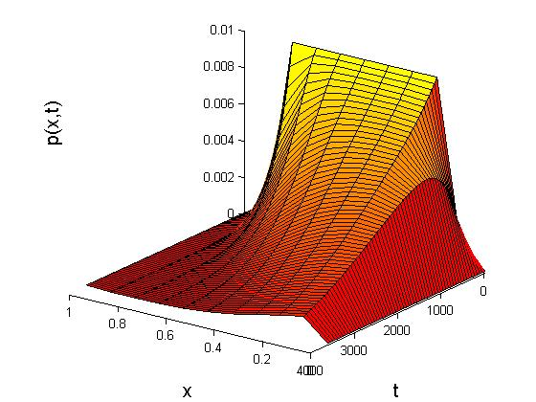

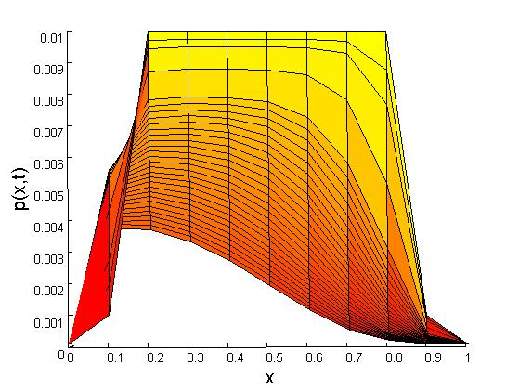
By using the method of Crank-Nicolson, the following relation was found;
This results in matrix form:

Discussion
Although the simulation did not succed as wished a process of diffusion is clearly distinguishable. The objectives of modification are clear; the computer program should be enhanced.

The method as is (Crank-Nicolson) clearly works satisfactory at this level, and it can be used further when adding the off states of the rotor. This would give a more complete picture of the process.

Other ways of improving these kind of simulations are of course a better knowledge of the constants and variables involved.

6 Appendix

clear all
L=1; % längd ca 10nm
dx=L/10; %Steglängd
x=[dx:dx:L-dx]; %Inre gitterpunkter i x-led
x1=[0 x L];
n=length(x); %Antal gitterpunkter
%
dt=0.05; %tidsteg
Fm=0.7*10^(-4); %F(n-1/2)
Fp=0.2*10^(-2); %F(n+1/2)
Bm=0.5*10^(-3); %B(n-1/2)
Bp=0.2*10^(-2); %B(n+1/2)
a=dt/2*Fm;
b=dt/2*(Bm+Fp);
c=dt/2*Bp;
C=-c;
f0=0.0001; fL=0.0001; %Randvillkor
%
Ap=sparse(diag((1+b)*ones(n,1))-diag(ones(n-1,1),1)*c-diag(ones(n-1,1),-1)*a); %Matris
Am=sparse(diag((1-b)*ones(n,1))+diag(ones(n-1,1),1)*c+diag(ones(n-1,1),-1)*a);
%
T=[0.001 ones(1,n-2)*0.01 0.001]'; %Begynnelsevillkor
T1=[f0 T' fL]';
T2(:,1)=T1;
%
h=[a*f0 zeros(1,n-2) c*fL]'; %Vektorn b
clf
k=1;
for t=dt:dt:60*60 %I en minut
T=Ap\(Am*T+h);
if fix(t/60)==t/60; %Plotta
k=k+1;
T1=[f0 T' fL]';
Tx(k)=t; %Spara tiden
T2(:,k)=T1; %Spara p för 3Dplot
end
surf(x1,Tx,T2'); %Tredimensionell plot
xlabel('x','Fontsize',15); ylabel('t','Fontsize',15); zlabel('p(x,t)','Fontsize',15);

colormap(autumn)
view([1 1 1]);
grid off
Referenser
MOLECULAR BIOLOGY OF THE CELL, Third edition
Bruce Alberts, Dennis Bray, Julian Lewis, Martin Raff, Keith Roberts,
James D. Watson. Garland Publishing Group, New York (1994)

General Chemistry, Third edition
John W. Hill and Ralph H. Petrucci.
Prentice Hall, New Jersy, (1996)

Biology, Fourth edition
Neil A. Campbell.
The Benjamin/Cummings publishing company, Inc. (1996)
Computational cell biology
Christpher P. Fall, Eric S. Marland, John M. Wagner, John J. Tyson.
Springer science, New York (2002)
ATP Synthase Motor components
David J. Blum, Young Hee Ko, Sangjin Hong, David A. Rini, Peter L. Pedersen
Doi:10.1006/bbrc.2001.5634, http://www.ideallibrary.com

