Modelling of an Oscillating
Chemical Reaction System

Examinator:
Alexei Heintz

Peter Mlinaric, F2 CTH
14 May 2005

Abstract

Most macroscopical systems of chemical reactions tends towards a stationary state, but there are also non-equilibrium systems with a large extent of order. Among them are oscillating chemical reactions, which are the issue of this study. Particularly a hypothetical chemical reaction system known as the Brusselator, which mimics real oscillating chemical reactions, is the set out point for this project. The studies are done in a both deterministic and stochastic way. Mathematically, the deterministic perspective allows to show under what circumstances the oscillations of the system exist. Phase analysis show how those reactions behave. Also, a stochastic approach on the modelling of the Brusselator is done. By the way of the studying, some restrictions on the Brusselator are done that are mathematically motivated.

Eventually, there is a discussion on the eligibility of letting the deterministic and the stochastic model describing the Brusselator under different circumstances. It is also shown how these two different approaches naturally transit into each other.

Background

The dynamics of oscillating chemical reactions has been studied since the middle of the last century, following that the chemist B Belousov in 1951, observed periodical changes of colour of a mixture of citric acid, bromate and cerium catalyst in a sulfuric acid solution. This was not expected to occur in a chemical reaction, since the oscillations at the time was believed to be in conflict with the therodynamic laws. Thus, nobody believed Belousov’s work, and his work remained unpublished for years.

In 1961 however, chemist A M Zhabotinskii reproduced Belousov’s results. He discovered stable oscillations in a similar reaction system, using malic acid as reductant. This time, the oscillation was not present as visible changes of colour, but as oscillations of the solution’s optical density and electric potential.

The reaction system, called the Belousov-Zhabotinskii reaction, has from then on been thoroughly studied and become the most famous chemical oscillation reaction. It has also influenced new branches of mathematical studies of oscillating reaction systems, among them Volterra-Lotka and Brusselator systems.

Contents
1. Introduction 5
1.1. Description of the Brusselator reactions 5
2. A deterministic perspective 6
2.1 The law of mass action 6
2.2 Stationary state and stability ODE-system 7
2.3 Bifurcation analysis 9
2.4 Poincaré-Bendixson theory 9
2.5 Phase analysis 11
3. A stochastic perspective 15
3.1 Brownian motion 15
3.2 Fokker-Planck equation 16
3.3 Stochastic trajectories 16
4. Discussion on the mathematical modelling 19
5. Conclusion 19
6. References 20
7. Appendix 21
Appendix A, Matlab code 21

1. Introduction

The mathematical modelling of an oscillating chemical system is set out from a hypothetical chemical reaction system called Brusselator. It was first studied by I. Prigogine in Brussels in 1971, hence the name. The Brusselator is an autocatalytic reaction, which means that species in the reaction also can act as a catalyst of the reaction. Those autocatalytic species in this system give rise to complex dynamics and cause the periodical oscillations which are the subject of our modelling. The aim of this study is to give a mathematical description of the Brusselator both from a microscopic as well as a macroscopic perspective. When the reacting molecules of the system are relative few, the reaction is a stochastic processes. As the number of molecules increase, the stochastic influences diminish, and the system can be modelled well in a wholly deterministic way.

1.1. Description of the Brusselator reactions

The chemical Brusselator reaction system is given by:

(1.1)

The rates gives the number of times that a reaction occurs in a volume at a given concentration, the stoichiometric coefficients tells how many molecules of a species are consumed or produced in each reaction.

For our modelling, we are interested in the concentration variations of the autocatalytic species denoted X and Y. They are both outputs and inputs in the reactions. For simplicity, we make our first restriction on the system. We assume that the reactions takes place in an open system, where the reactant species A, B, D and E are in large excess. Therefore, their concentrations are approximately constant, mathematically described with zero time rate change.

2. A deterministic perspective

We first investigate the Brusselator in a deterministic way. We assume that the number of molecules is very large so that we get a approximate continuity enough to allow us to differentiate. By studying the dynamics of ordinary differential equation systems, we can examine bifurcation and motivate the existence of those stable yet oscillating solutions that we are out for.

2.1 The law of mass action

A trivial chemical reaction, where two reactants forms a product can be represented as below.

By the law of mass action, which is valid if the number of reacting molecules is large, is at this point assumed to be a veracity. The reaction rate k is proportional to the concentration of the reactants. Mathematically this is stated as below, where A and B denotes the concentrations of the species respectively.

A is consumed, thus the time rate of change is negative.

By applying the law of mass action to each of the reactions in the chemical system (1.1), we are able to derive the following non-linear system of ordinary differential equations (ODE) for X and Y:

(2.1)

For clarifying qualitative properties of the reaction, the equation system (2.1) has to be rewritten in an equivalent non-dimensional form, so that we can compare the quantities.

The loss of dimensions can be carried out by introducing the dimensionless variables u and v proportional to X and Y respectively (dimensionless concentrations) and the also dimensionless parameters a and b each of them proportional and equal in sign to the constant concentrations of A and B respectively

By a restriction to our chemical reaction model, usually done to the Brusselator, all rate constants are set equal to one. We achieve a ODE-system pure in style.

(2.2)

While the Brusselator models a physical reaction, natural restrictions are that u, v, a and b are non-negative and real valued. Further, in order to make the chemical reaction system (2.1) occur, we must call for that both thus our additional claim is .

2.2 Stationary state and stability ODE-system
The properties of the system do to a large extent depend on its stationary states, which we get by solving the ODE-system (2.2) for left hand sides zero.

(2.3)

The one and only stationary point of the system is then given to be (1,b/a) in the (u,v)-plane. This is the equilibrium of the chemical reaction.

To determine the stability, we make a linear approximation of the system, which serves as a valid modelling of the system in some neighbourhood of the stationary point. We use the first term of the Taylor expansion, thus calculate the Jacobian matrix of the system.

The eigenvalues of the Jacobian matrix evaluated at the stationary point provide us with information about the stability of the equilibrium.

(2.4)

We can expect several stationary point types for the dynamic system depending on a and b (fig. 2.1), and we can also state that b – a <1 implies stability, manifested by the stationary point beeing attractive. On the other hand, if b – a>1 the chemical system will evolve from the equilibrium state. To track the oscillations in the chemical reaction system, we need a neutral centre in the linearized system, that is . The imaginary parts of the eigenvalues are the sources of oscillating solutions (cf. Eulers formula for imaginary numbers), and pure imaginary eigenvalues equips the linearization with a centre in the phase plane.

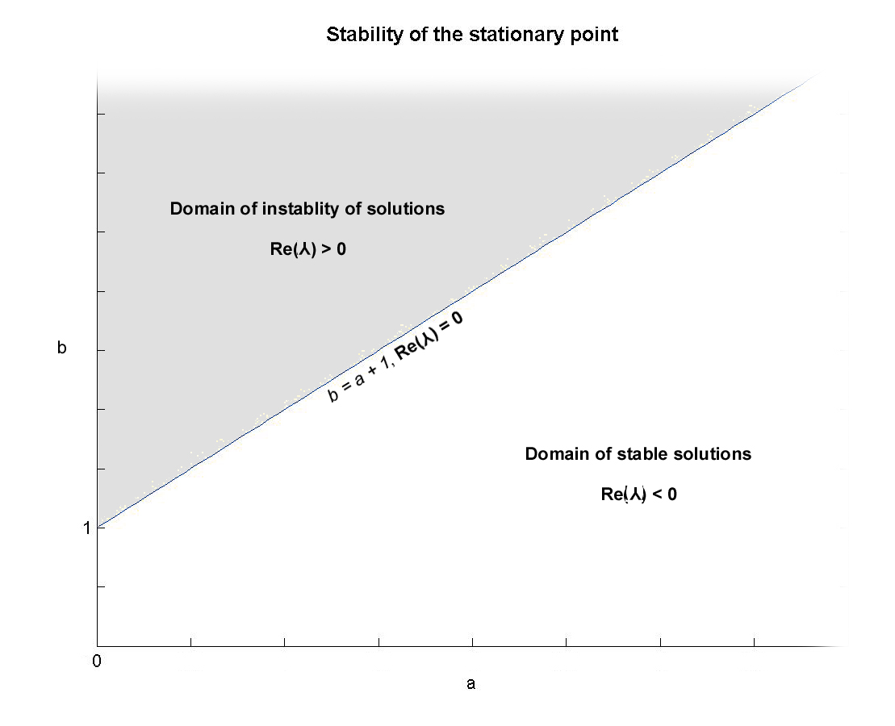
Fig 2.1. How the stability of the linearized system varies with parameters.

2.3 Bifurcation analysis

Bifurcation from equilibrium solutions is related to the stability of the stationary states. The qualitive nature of solutions to differential equation can change as a parameter varies.

We turn to the Hopf bifurcation theorem. In accordance with it, we will mathematically motivate the existence of stable oscillating solutions by proving the existence of oscillating solutions of a limit cycle. Without loss of generality, assume that a is fixed. On the line b = a + 1 we have a centre in the linear model around the stationary point, and the eigenvalues of the Jacobian matrix where pure imaginary and distinct from zero as shown (2.4). With respect to the variations of the parameter b, the rate of change of the real part of the eigenvalue needs to be distinct from zero. This follows trivially:

By the Hopf bifurcation theorem, the system contains an isolated limit cycle.

2.4 Poincaré-Bendixson theory

We now analyze the ODE-system from perspectives of the Poincaré-Bendixson theorem. The isoclines for which the time rate of change of u and v is zero, the nullclines, are calculated by letting the left hand sides in the ODE-system equal zero, similar to (2.3). But expressed as v(u), the u-cline and the v-clines are

.

They nullclines are illustrated in fig 2.2.

The Poincaré-Bendixson theorem tells that if we have a region in the phase plane that is a closed, bounded and positively invariant set, then there must be a limit cycle in the region, also referred to as Bendixson region. We then construct such a region from our knowledge of the clines.

Let b be slightly larger than a + 1. Then we know by fig 2.2 that the stationary point is unstable. By definition of an unstable point, we know that there exists a circular neighbourhood where all flow is directed out from the circle. We then need a region outside this circle where the net flow is inwards, so that the region is positively invariant.

We take the simple borders just by inspecting fig 2.2. The cline v₂ = 0 will do. Also, in the region limited by the vertical axis together with the isoclines, we can draw a vertical border from intersection of u and v₂, till it intersects v₁. Another vertical line where u equals a constant larger than the u component of u and v₁ cline intersection will do as the rightward border up to the intersection with the u cline. From the field vectors we also see that a horizontal line as upper border from the end of the left border has a inward net flow. However, to continue the right border vertically till intersection with it, will dispose of the positive invariance. Therefore, we observe the direction of the field between the upper and the rightward borders, and connect them graphically with a diagonal line segment such that the closed, bounded region is positively invariant. Thus, we have our Bendixson region (fig 2.3).

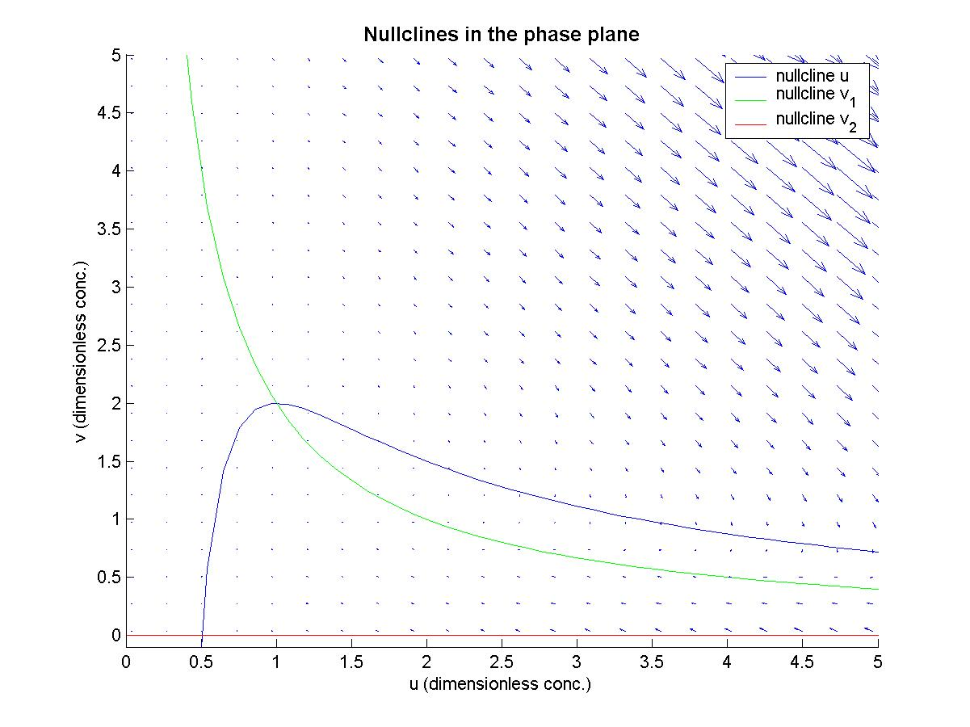
Fig 2.2. The isoclines of stationary concentration for fixed a and b

This procedure repeated for other values of the parameters a and b shows that the Bendixson region expands with growing parameter b, when a is fixed. This indicate that the diameter of the limit cycle grows, thus the concentration oscillations grow in magnitude. This describes how we for different specific concentrations of species A and B can get periodical oscillations of lesser or greater magnitude, thus less or more easy to visually observe. We shall continue with the phase plots.
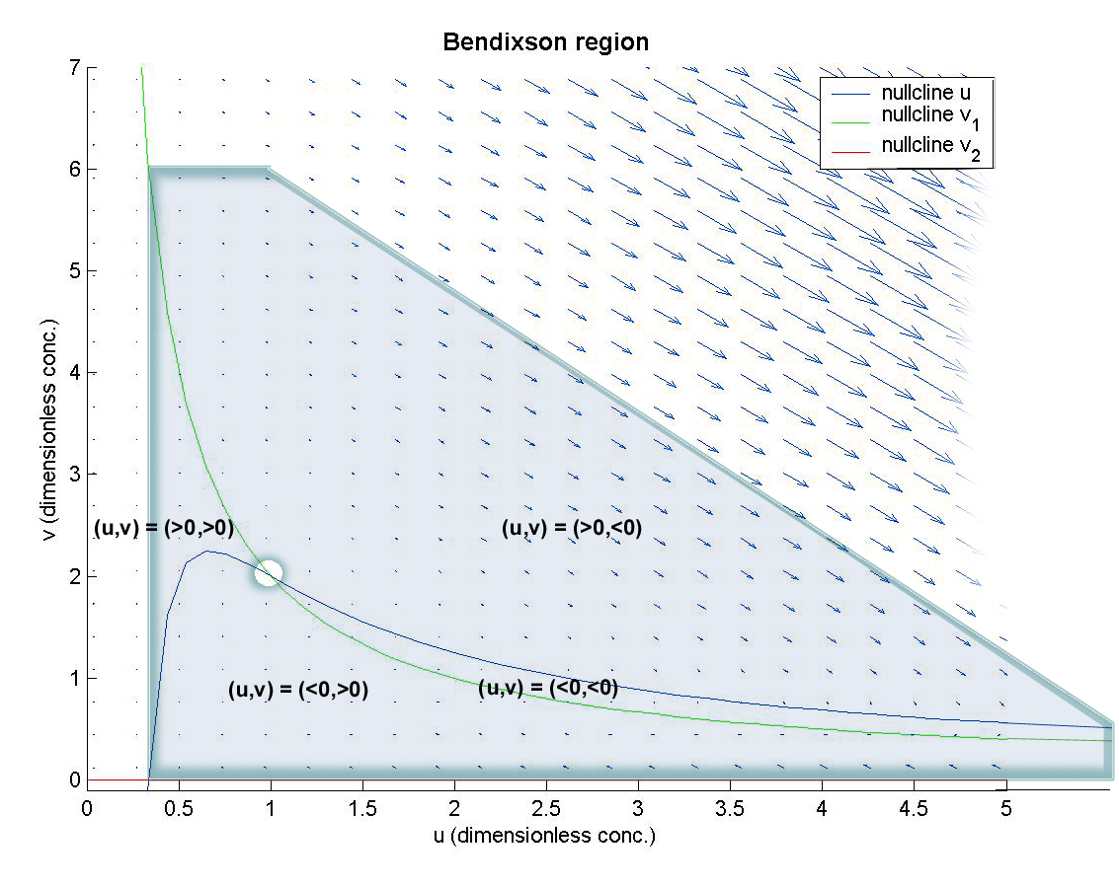

2.5 Phase analysis

Now we use a phase plane analysis to confirm our results. Fig. 2.4 shows the phase portrait for such parameter values that we have a stable stationary point. By increasing the parameter b till we land on the line
b = a + 1, the stability is unsecure (fig. 2.5). When then concentration of species A and B are such that the parameters become b > a + 1, we have a stable limit cycle that the Hopf bifurcation theorem predicted. Thus, the chemical reaction systems have stable oscillations. For growing b, the radius of the limit cycle grows (fig. 2.7), as theoretically shown. Fig 2.8 shows time plots of the dimensionless concentrations u and v. We see that the oscillations are stabilized. According to Hopf bifurcation theorem, the frequency of the oscillations is near to the absolute value of the imaginary part of the eigenvalues to the ODE-system.

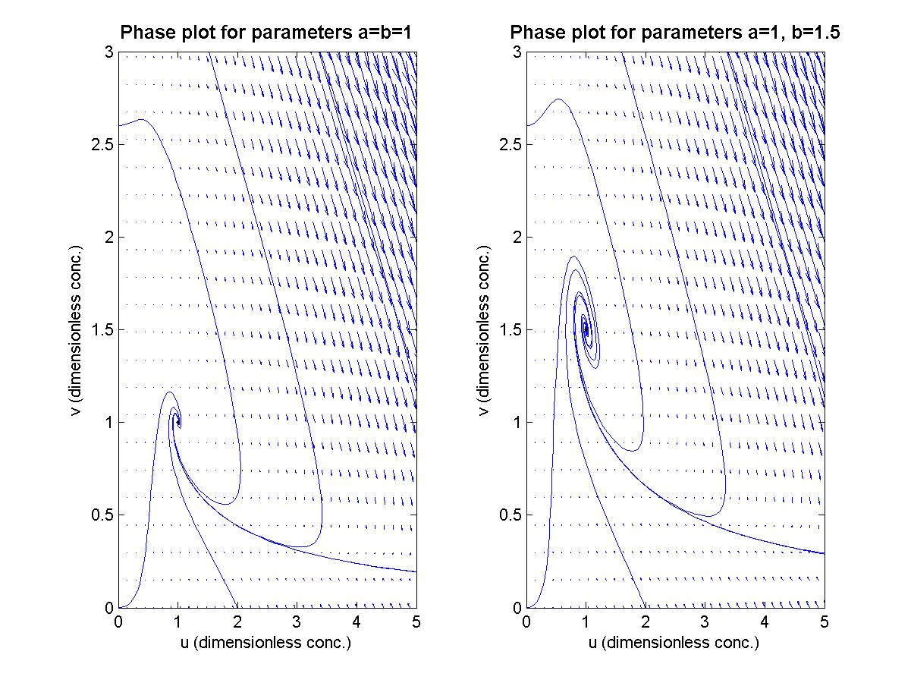
Fig 2.4. The stationary point is stable. However, growing parameter b makes it loose attraction, visualised by the more twining trajectories.

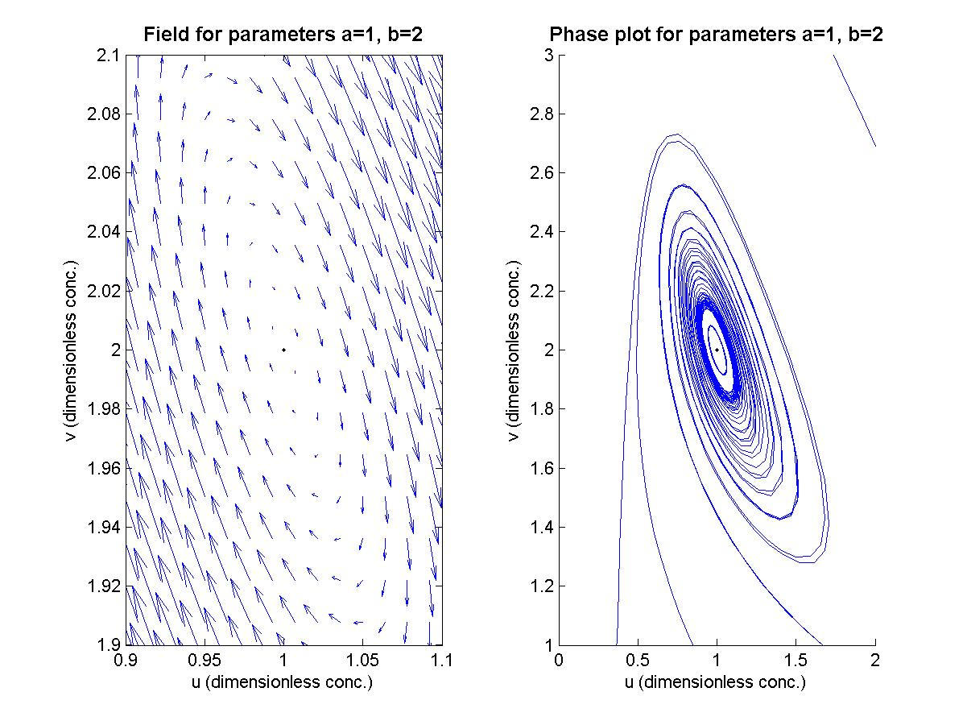
Fig 2.5. This is the borderline case, where the linearized system has a neutral centre. From the phase plots, it is impossible to tell whether we already have a limit cycle or not.

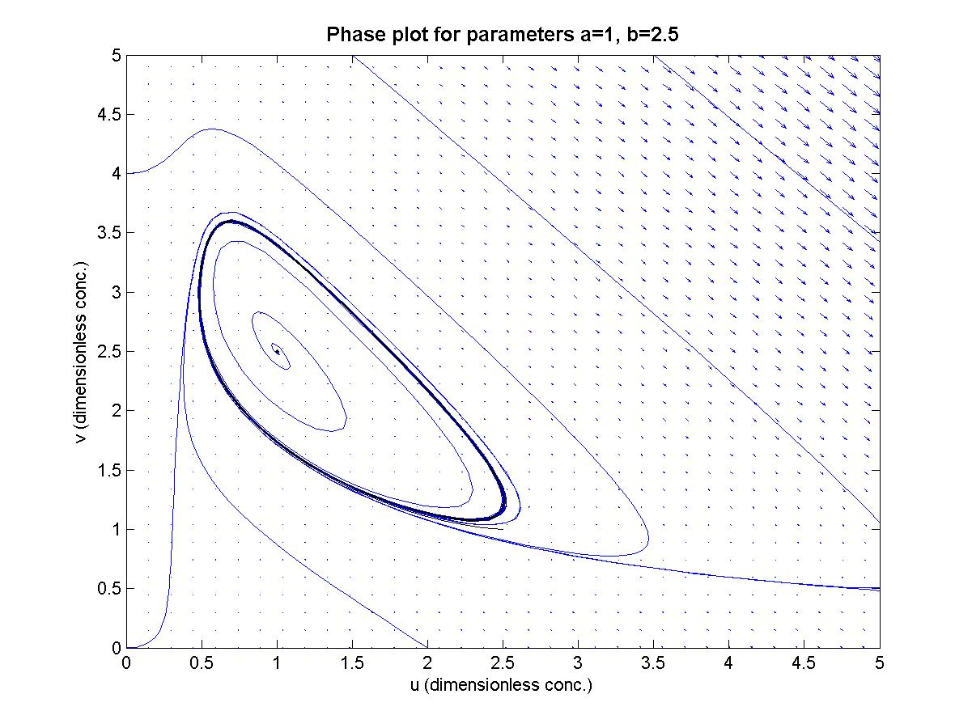
Fig 2.6. A stable limit cycle has now appeared (black). The stationary point thus is a repellor.

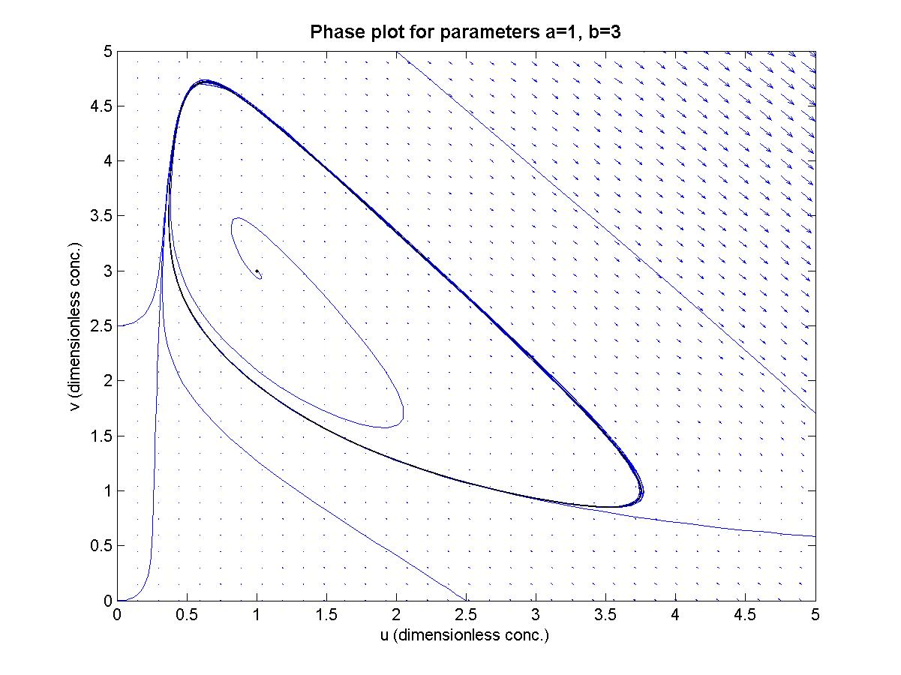
Fig 2.7. As mathematically predicted, the magnitude of the stable oscillations grows with b.

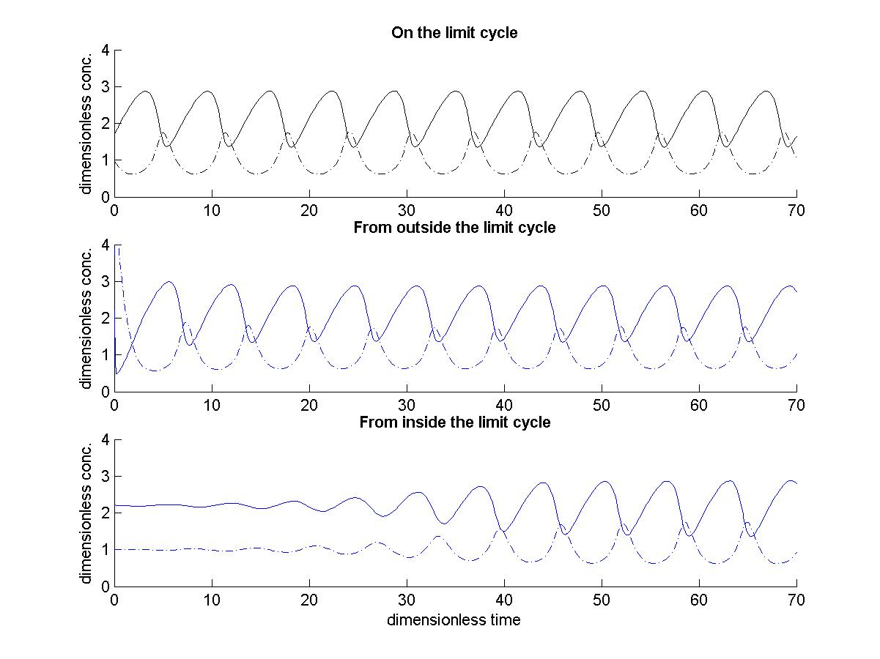
Fig 2.8. A time plot of the concentrations (broken line is u). The system of chemical reactions unavoidably ends up in periodical oscillations for a and b such that we have a limit cycle, irrespective of the initial values of u and v.

3. A stochastic perspective

The deterministic model presented above uses the law of mass action as a fundament. In reality the mass action assumption is true only when there are about ten thousands or more molecules taking part in the reaction. In for instance biological reactions, which the Brusselator sometimes is used to mimic, the number of reacting molecules could be less. Essentially, chemical reactions are stochastic processes occurring with some probability.

3.1 Brownian motion

To describe the macroscopic system, one introduces the probability distribution P(n_{x},n_{y},t) of having a number n_{x} of X kind molecules and a number n_{y} of Y kind molecules. The stochastic kinetics can be modelled like a Brownian motion where the number of molecules for each step discretely is increased or decreased by one (1). Fig 3.1 shows an simulation of such kind of two-dimensional mathematical Brownian motion (see Appendix A.4 for implementation).

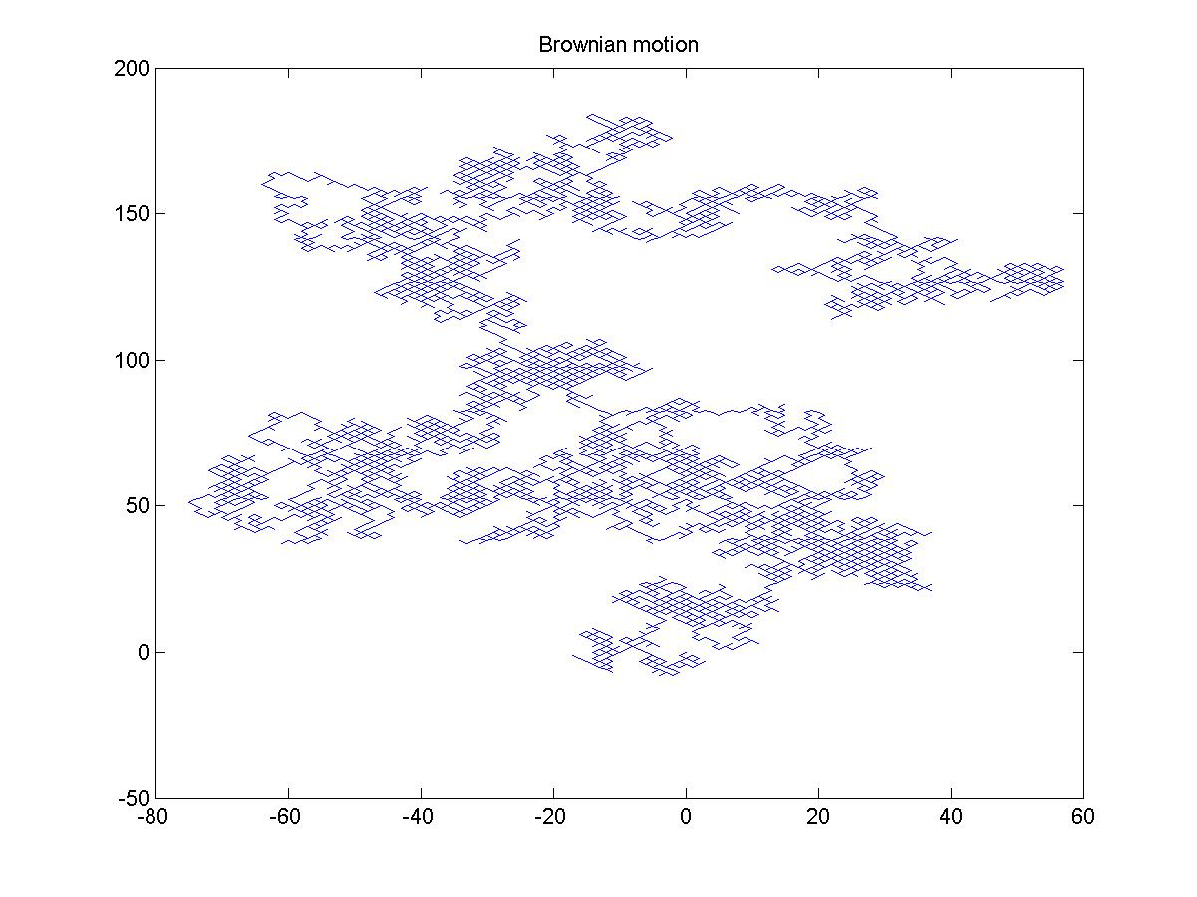
Fig 3.1. Two-dimensional brownian motion simulated with 10 000 steps, starting out from origo.

From each couple of numbers (n_{x},n_{y}) the system moves farther to one of four neighbouring couples, due to a positive or negative unit change in one of the numbers of the couple. The move is governed by rate constants of the chemical reaction, resulting in a stochastic compartmental system.

3.2 Fokker-Planck equation

If one assumes the probability distribution function P(n_{x},n_{y}) to be continuous and considers what restrictions this may imply to the model, one can make the stochastic system easier to analyse or solve numerically. Continuity allows terms within the stochastic compartmental system to be replaced by partial derivatives of P with respect to n_{x} and n_{y}. For the further investigation we will use a source protected software for phase simulation of the Brusselator, which forces us do rewrite the reaction system (1.1) in another non-dimensional form (Appendix B). The stochastic Brusselator can then be described by a partial differential equation (PDE) when Brownian motion transits to diffusion. The PDE is known as the Fokker-Planck equation

(3.1)

where D is the drift vector and D² the diffusion tensor. Equation (3.1) can be rewritten as

. (3.2)

The leftmost term is a diffusion term proportional to σ in its part proportional to u/n_{x} or v/n_{y}. σ is 1 when the molecules are few, but tends to zero as they increase. In the same time, the rightmost term in (3.2) tends to the deterministic ODE-system (cf. 2.2 and Appendix B).

3.3 Stochastic trajectories

The stationary density of the stochastic Brusselator is computed by means of a Monte Carlo simulation which counts how often a grid of bins is visited by a trajectory of the stochastic Brusselator. Following is a numerical study for fixed parameters a and b (thus specifying the same limit cycle), but varying parameter σ.

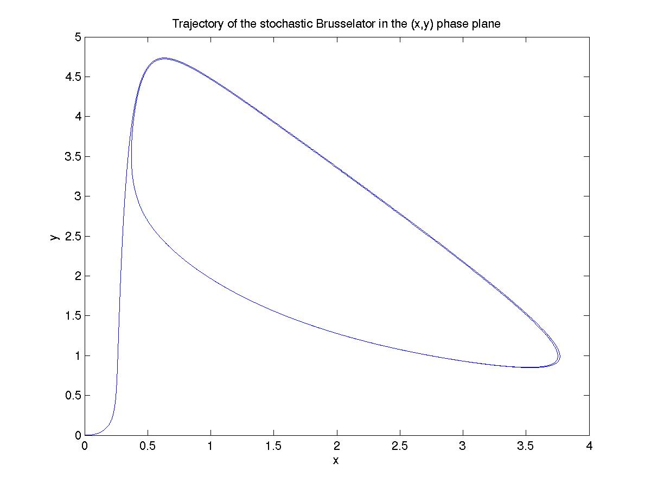

Fig 3.2. σ = 0, the number of molecules are large. The trajectories verify the statement about transition to the deterministic model.

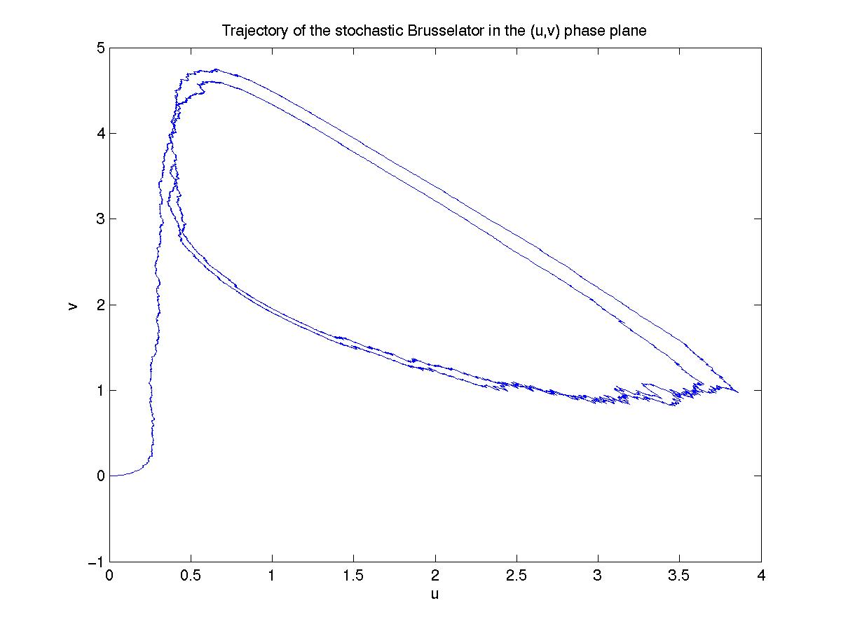
Fig 3.3. σ = 0.1 and near its downward limit. Some random motion in the phase plane is observed. The system cannot trace back its root in each cycle.

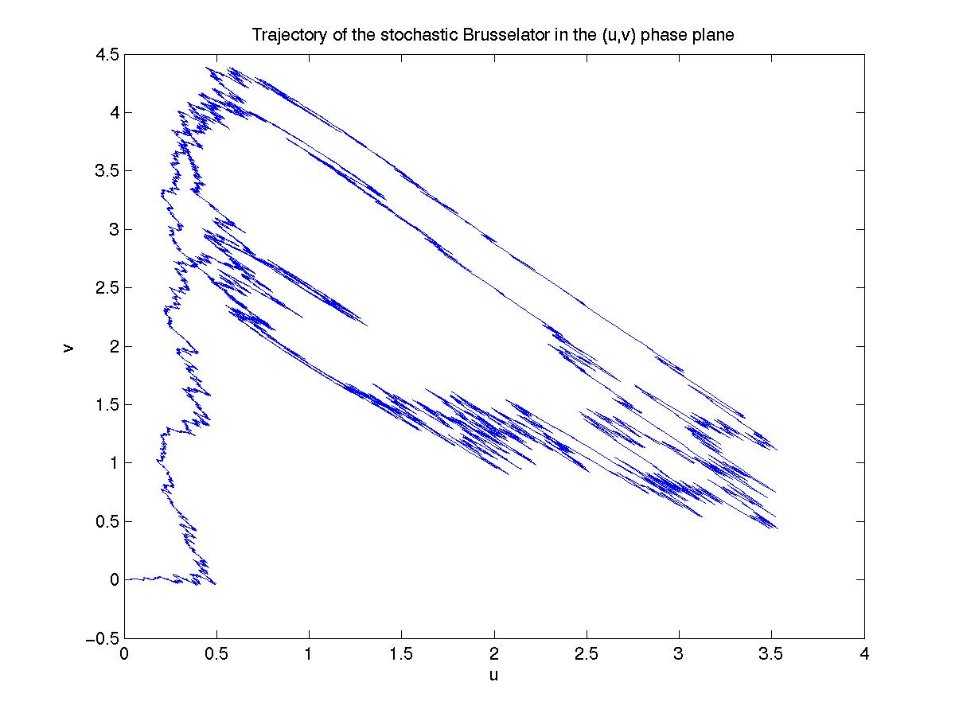
Fig 3.4. Trajectories for σ = 0.5. Gradually, the limit cycle is loosing its shape.

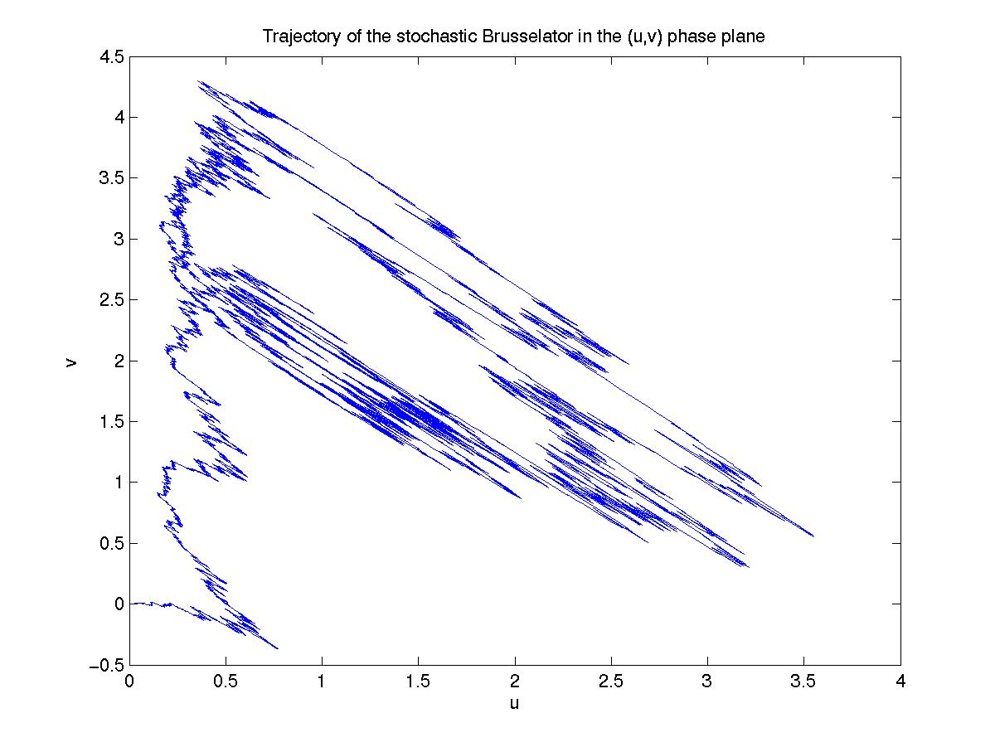
Fig 3.5. Trajectories for the maximal σ = 1, meaning few reacting molecules. The shape of limit cycle is ruined by the force of the stochastic component.

4. Discussion on the mathematical modelling

When basing the mathematical model on the Brusselator, one can disregard of the limitations of a discrete chemical description (1.1) describing continuos lapse. For although the system of reactions is a mimic of a real chemical reaction, its chemical reactions fully determined. Non-hypothetical systems may be less reliably descriptions of the an actual reactions, because they must discretisize the continuous reaction in a limited time interval.

A model that lack restrictions may be impossible to do. The restrictions made in this study were mathematically motivated to simplify calculations. In real, such restrictions, maybe of reaction rates, will manipulate the activation energy of the reactions to levels that are not chemically possible and so on. However, this study is done from a mathematical point of view, maybe sometimes to irrespective of the chemistry and physics of in the reactions.

5. Conclusion

With the introducing deterministic analysis, mathematical theory was let to predict the non-linear dynamics of the chemical reaction system. With bifurcation analysis and Poincaré-Bendixson theory as tools the existence of stable oscillations was shown as well as under which circumstances they occur and how they behave.

The deterministic and bifurcation analysis was valid in a macroscopic system. Then the amount of forward and reverse reacting molecules is proportional to their densities, the law of mass action is valid. When the number of molecules is small, the system is microscopic. The reactions are more random than for observations across a system with a large number of molecules and there is no obvious manifestation of bifurcation. Brownian motion can mathematically model random movements. Stable oscillations demand a rather large number of reacting molecules.

Whereas the ODE-system shows how the system changes with time, the master equation shows how the probability of the system being in a certain state changes with time. Thus models the two models used were of different, stochastic respectively deterministic, nature. This chemical reaction is an example where the two different kinds of models are no alternatives to each other, but both describes the reaction under different circumstances. We have shown that this distinct scopes in a natural way run into each other and the stochastic model converges to the deterministic one. In the same time, the stochastic model is more complete as it models reactions with both microscopic and macroscopic systems.

6. References

Literature:
Qian, H; Saffarian, S; Elson; E L; Concentration fluctuations in a mesoscopic oscillating reaction system, PNAS no 16/vol 99, 6 August 2002

Ault, S; Holmgreen, E; Dynamics of the Brusselator, 2003, www.math.ohio-state.edu/~ault/Papers

Nelson Edward, Dynamical Theories of Brownian Motion, 1967, out of print, from www,math.princeton.edu/~nelson/books.html

Lecture notes from the course

Internet:
Author unknown, Fokker-Planck equation, may 2005 http://en.wikipedia.org/wiki/Fokker-Planck_equation

Author unknown, Brownian motion, may 2005 http://en.wikipedia.org/wiki/Brownian_motion

Yang L, Brusselator, may 2005
http://hopf.chem.brandeis.edu/yanglingfa

7. Appendix

Appendix A, Matlab code

A.1 The deterministic ODE system function file

%Function m-file oscill1.m

function oscill =oscill1(t,x)

global a;
global b;

%Let x(1)=u, x(2)=v, xprim=[uprim vprim]'

oscill=[(1-x(1)*(b+1)+a*(x(1)^2)*x(2));(b*x(1)-a*(x(1)^2)*x(2))];

A.2 General program for the phase plots

%Phase plot commando file

clear

clf
clc

global a b
a=1;
b=1.5;

%Fieldvectors

u=linspace(0,5,36);
v=linspace(0,5,36);
[U V]=meshgrid(u,v);

dU =1-(b+1).*U + a.*(U.^2).*V;
dV = b.*U - a.*(U.^2).*V;

quiver(U,V,dU,dV,5)

hold on

%Solutions of the system oscill1 calculated with ode45
%in adequate time intervals

[tida,xida]=ode45(@oscill1,[0 20], [0 4]);
plot(xida(:,1),xida(:,2));

[tidb,xidb]=ode45(@oscill1,[0 20], [1.5 5]);
plot(xidb(:,1),xidb(:,2));

[tidc,xidc]=ode45(@oscill1,[0 20], [0 0]);
plot(xidc(:,1),xidc(:,2));

[tide,xide]=ode45(@oscill1,[0 10], [3.5 5]);
plot(xide(:,1),xide(:,2));

[tidf,xidf]=ode45(@oscill1,[0 50], [0 2.6]);
plot(xidf(:,1),xidf(:,2));

[tidg,xidg]=ode45(@oscill1,[0 50], [2 0]);
plot(xidg(:,1),xidg(:,2));

plot(1,b/a,'.k') % The stationary point

xlabel('u (dimensionless conc.)')
ylabel('v (dimensionless conc.)')
title('Phase plot for parameters a=1, b=1.5','FontSize',12,'FontWeight','bold')

axis([0 5 0 3]);
hold off

A.3 General program for the time plots

%Time plot commando file

clear
clf
clc

global a b
a=1;
b=2.2;

subplot(3,1,1);
[tid,xid]=ode45(@oscill1,[0 70], [1 1.7]);
hold on
plot(tid,xid(:,1),'-.k');
plot(tid,xid(:,2),'k');
title('On the limit cycle','FontSize',10,'FontWeight','bold')

ylabel('dimensionless conc.')
axis([0 70 0 4])

subplot(3,1,2);
hold on
[tida,xida]=ode45(@oscill1,[0 70], [3 3]);
plot(tida,xida(:,1),'-.');
plot(tida,xida(:,2));
title('From outside the limit cycle','FontSize',10,'FontWeight','bold')
ylabel('dimensionless conc.')
axis([0 70 0 4])

subplot(3,1,3);
hold on
[tidb,xidb]=ode45(@oscill1,[0 70], [1 2.21]);
plot(tidb,xidb(:,1),'-.');
plot(tidb,xidb(:,2));
title('From inside the limit cycle','FontSize',10,'FontWeight','bold')
xlabel('dimensionless time')
ylabel('dimensionless conc.')
axis([0 70 0 4])

hold off

A.4 Simulation of Brownian motion

%Brownian motion commando file.

n=10000
p=.5
nx=[0 cumsum(2.*(rand(1,n-1)<=p)-1)];
ny=[0 cumsum(2.*(rand(1,n-1)<=p)-1)];
plot(nx,ny);
title('Brownian motion')

Appendix B

Nondimensional form

Translation

Appendix C

The Stochastic Brusselator

A Monte Carlo simulating software for the Brusselator, developed by L Arnold, G Bleckert and K Reiner
Received from www.schenk-hoppe.net/numerics/brusselator/brusselator.html

