The 2010 flash crash
Reading project in MVE220
^{11TH OF MAY 2018}
HAMPUS FRODELL & JOHAN HÄRDIG

Innehållsförteckning
1. The event 3
1.1 Context 3
1.2 Happening 3
1.3 Aftermath 4
2. Background 5
2.1 The face of the crash 5
2.2 Automated trading 6
3. Analysis 7
3.1 Consequences 7
3.2 Conclusion- 7
4. References 8

1. The event

1.1 Context
In the wake from the financial crisis of 2008, stock markets around the world saw a steady but slow recovery. In the late spring of 2010, economic factors like the debt crisis in Greece made the markets, including the American, more shaky then it had been since the big crisis took place two years earlier. But it was not the greeks missing capabilities of paying the government debt that made the 6th of may 2010 into one of the american stock markets most interesting days. It was a United States trillion dollar stock market crash, that most of us never heard of.

The Flash Crash, The 2010 Flash Crash or the Crash of 2:45 pm, was a crash that has been described as one of the most turbulent and volatile times in all of history of financial markets.

Before we move in to the interested stuff we want to note. The explanations of the flash crash are both many and diverse. In fact, there is not a single theory that has been identified as the reason behind the big plunge. But there are several which you can read about, some more technical that involves the marketstructure and some that points to human mistakes. The one explanation we are going to discuss involves and combines some of the biggest and most common ones. With that said, everything we are about to say is true with respect to our resources, but it is up to everyone themselves to evaluate how big of a contribution everything has.

1.2 Happening
Right before the big breakdown around 2.30, a big trader started selling something that's called E-mini contracts. E-mini is a stock market index futures contract and to make it understandable in this context, it´s basically a contract that is worth 50 times the value of the S&P 500 stock index. The way the trader did it was via an algorithm that did not take in regard what time or price it was, only the execution rate. His automated selling strategy resulted in a huge amount of money being moved in the market, which according to a report by the SEC (The Securities and Exchange Commission) and CFTC (Commodity Futures Trading Commission) was approximately 4.1 billion dollars. According to some research, this trader made the move that is the cause and start of the flash crash, but we will come back to this trader and his methods.

Independent of what was actually set of the flash crash, the big net change resulted in a heavy pressure on high frequency traders and led to “hot potato” trading which spread through the market in just a few minutes. So when the price started dropping, the high frequency traders contributed to an even more rapid change. We will talk more about high frequency tradeing and from know on call it HFT.
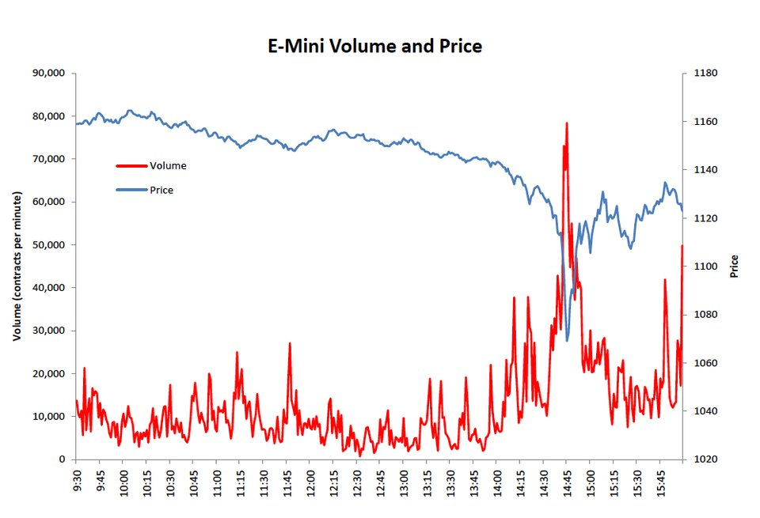
Figure 1: Illustration of E-Mini Volume and Price at 6th of may.

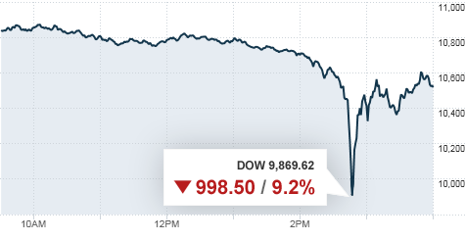
So the prices on the E-minis dropped and the trading volumes reached record highs as seen in figure 1. Of course, this affected all financial markets and left a remarkable result. Dow Jones industrial average, dropped more than 9% in about 10 minutes. So it did not matter if you were a big holder of E-minis or a regular private investor, everyone got affected. The total loss for the 10 minutes of craziness was more than a trillion dollars. A trillion dollars is equal to a million millions. So in SEK, the market value lost around 8.5 trillions SEK which is twice the swedish GDP (Gross national product).
Figure 2: Dow Jones index at 6th of may

1.3 Aftermath
As seen in the figures, the market corrected itself and went up in almost the same rapid way it went down. On the market were E-minis and other futures are traded they paused the trading for five seconds, which caused an interruption in the algorithms and therefore stopped the downfall. The interruption stabilized the price, and very soon it corrected itself, basically thanks to the same mechanisms that got the snowball rolling downhill in the first place. Traders that contributed to the quick correction where among others, HFT and opportunistic traders that saw a big opportunity in the downfall. The correction was almost so big that it reached the level where it was right before the drop.

So the market made a huge drop, but then reestablished very quickly, so maybe it was not that big of a crisis. But the Flash Crash affected all the financial markets in the U.S in a such rapid way that people started to question the mechanism of the new electronic markets that were automatic and robotized. Especially, the HFT got questioned. Because whatever set of the big drop, several reports points to that HFT played an important role and that this market structure has its risks that had not been discussed before.

Later on, a survey done by Market Strategies International, an American research company, showed that “over 80 percent of U.S. retail advisors believed that overreliance on computer systems and high-frequency trading were the primary contributors to the volatility observed on May 6, 2010. Calls for stricter regulation or even an outright ban of high frequency trading quickly followed.”. We will later on talk more about the impact with the following rules and regulations, but it is important to state that the Flash Crash brought some necessary questions up to the air regarding HFT.

2. Background

2.1 The face of the crash
So the crash of 2010 was due to many different factors. Even though it is hard to accuse specific individuals or institutions, there was one trader who was to become the face of the financial crash, Navinder Singh Sarao, a young british trader. He lived in his mothers basement and had an extreme interest and skills in finance and financial mathematics. During the year of 2009 he increased his fortune from 461 000 pounds to close to 15 million pounds, this before he hired a programmer to build the algorithm that made him infamous and was to give him blame in the crash. The algorithm used so called “spoofing trading” which, very simplified, means that you put lots of buy and sell orders on different prize levels to lure other programs and traders to a certain prize level and then withdraw the orders before they are executed.

In 2015, still living in his mothers basement, Navinder was arrested by the british police. He was accused of 22 criminal counts including fraud and market manipulation and charged with 38 million dollars in penalties. Money he easily should have been able to pay due to the enormous earnings from his trading, but since he had chosen to hide all his profits in offshore-companies to avoid paying taxes this was not possible.

Navinder and his lawyers agreed to pay the penalty and would, by doing so, help the government to find and secure the money he had hidden offshore. When they were trying to reclaim it all it turned out that Navinder had been scammed and the money was gone. As Navinders lawyer said in court, “basically, he has some extraordinary abilities with respect to pattern recognition and certain sorts of mathematical abilities, but he has some fairly severe social limitations.”

Navinder was later released from prison, with a gigantic penalty to pay the government and a trading ban, meaning that he could not trade on any stock exchange. One of his lawyers told the media regarding the penalty, “If they really want it, they could always lift the trading ban, one associate quips: He’d make it back in no time.”

2.2 Automated trading
And for you who does not know how HFT works, or the idea behind it, we present some of the main strategies used within HFT/automated trading.

Automated trading makes up a very big part of the volume on stock-exchanges and other markets. During 2014 the automated trading stood for more than 75% of the total volume on stock-exchanges in USA. Often an automated trading-algorithm is built by testing a certain idea and then backtesting it on historical data. There are several different types of automated trading systems:

- Market maker: Provides liquidity in the market for other investors and is therefore ready to buy or sell a stock at any given time.

- Ticker Tape trading: A “primitive” strategy where the system simply overlooks the price of the stock and the volume in the market to find unusual events. For example if a pension fund decides to buy a large amount of shares in stock A they will need to to this over several hours to find the liquidity and therefore it will be an increase in the volume and then the system can “understand” that there is a big buy happening, therefore buying themselves.

- News based-trading: If a company sends out news in electronic format programs can ready and identify keywords in the text. For example if a press release have the words CEO and “sell” it probably is saying that the CEO of the company is selling his shares, and then the program should short the stock.

- Low latency-strategies: If you have a shorter time-delay to the stock-exchange you could utilize arbitrage possibilities before the market corrects it. Microwaves travels faster than fiber-optics.

3. Analysis

3.1 Consequences
There was a need to impose new regulations to reduce the risk of new flashcrashes or other similar situations that could harm the market. Trading curbs, or circuit breakers, were installed on stocks of the S&P 500 that meant if one stock rose or fell more than 10% in a five minute period the trading in the stock was halted. This happened for the first time in June 2010 where Washington Post Companys stock fell rapidly. The cause of the problem was some erroneuos orders on a option-exchange.

The portion of the total trading coming from high frequency-trading had declined from 61% in 2009 to 53% in 2011. Due to the decreased volatility and volume in the stock-market some of the high frequency-trading were moved to other markets, such as commodities and currencies. This led to some similiar effects on these markets as on the stock-market, with some “flashcrashes” occuring. In 2011 the sugar-prize fell 6% in one second, cacao fell 13% in one minute and the dollar-yen currency-pair fell 5% in one minute (which is a lot in currency).

3.2 Conclusion
The thing that we find most interesting about the topic, is the fact that regardless of the amount of data that has been analyzed, no real explanation exists. The conclusions that SEC and CFTC made has been highly criticized, which proves the uncerainty even more.
It is said to be the five most turbulent minutes in American stock market history, but still there is no explanations or reports where the data is used to get it all covered. This makes it even more interesting for us that is interested in financial risk analysis. How should all this data be analyzed? How could you prevent this type of events from happening again, creating big financial losses and building skeptesism towards the new type of markets that’s supposed to create new opportunities?

Through the data and reports we have been reading, we have come to the conclusion that high frequency trading has an impact on the market in the shape of instability. The fact that it exists several explaniations to this event does not mean that you can exclude HFT:s negative impact, if it is not regulated. As we earlier mentioned, parts of that type of trading moved to other markets and led to crashed in for example commodities. Our conclusing is that it always should exist regulations, either volumebased, since it in our case where used an algorithm where time and price where excluded. A limit on volome and excecutionrate could possibly have prevent the flash crash. Limits on percentagedrops with respect taken to time, should also exist on lower levels, since the automated markets these days can have huge impacts in very little time. A reason for this is the flash crash itself, the big drop happened extremely fast and where also stopped thanks to limits and stop-functions.

We see the flash crash as a result of several factors. In some parts we did have an unstable market, where new methods and automated markets where not completely regulated. Maybe it was that simple that it only took a specific trade to get the ball rolling. When the ball then was rolling, HFT and the automated markets then made the event into something that goes to the history of the American stock market.

4. References

Downloaded 15 of april 2018
https://www.cftc.gov/sites/default/files/idc/groups/public/@economicanalysis/documents/file/oce_flashcrash0314.pdf

https://www.ekonomifakta.se/Fakta/Ekonomi/Tillvaxt/BNP---Sverige/

Liam Vaughan, Bloomberg, February 10th 2017
https://www.bloomberg.com/news/features/2017-02-10/how-the-flash-crash-trader-s-50-million-fortune-vanished

Tomoeh Murakami Tse, Washington Post, June 17th 2010
http://www.washingtonpost.com/wp-dyn/content/article/2010/06/16/AR2010061604557.html

https://en.wikipedia.org/wiki/2010_Flash_Crash

SEC & CFTC,
https://www.sec.gov/news/studies/2010/marketevents-report.pdf

Kirilenko, Andrei A. and Kyle, Albert S. and Samadi, Mehrdad and Tuzun, Tugkan, The Flash Crash: High-Frequency Trading in an Electronic Market (January 6, 2017). Journal of Finance, Forthcoming. Downloaded 15 of april at SSRN: https://ssrn.com/abstract=1686004.

http://www.cmegroup.com/trading/equity-index/us-index/e-mini-sandp500_contract_specifications.html

Figure 1: http://www.businessinsider.com/charts-what-happened-during-flash-crash-2010-10?r=US&IR=T&IR=T

Figure 1:
http://money.cnn.com/2010/10/01/markets/SEC_CFTC_flash_crash/index.htm

Readinglist

If you want to read more about this High frequency trading, we recommend you to look at Bil Conelys article in forbes, explaining it in a simple way:
https://www.forbes.com/sites/billconerly/2014/04/14/high-frequency-trading-explained-simply/#2579ef183da8

If you want to dive deep into the Flash Crash, we recommend you to look at the report which
U.S. COMMODITY FUTURES TRADING COMMISSION present on their website. https://www.cftc.gov/sites/default/files/idc/groups/public/@economicanalysis/documents/file/oce_flashcrash0314.pdf

