LINEAR MIXED MODELS FOR LONGITUDINAL DATA:
SAMPLE QUESTIONS FOR FINAL WRITTENEXAM, MAY, 20th 2009

- A study was conduced in West Java, Indonesia, to determine the effiects of vitamin A defficiency in preschool children. The investigators were particularly interested in whether children with vitamin A defficiency were at increased risk of developing respiratory infection, which is one of the leading causes of death in this part of the world. 250 children were recruited in the study, and their age in years, gender (0 =male, 1 =female), and whether they suffiered vitamin A defficiency (0 =no, 1 =yes) was recorded at an initial clinic visit (time 0). Also recorded was the response, whether the child was suffiering from a respiratory infection (0 =no, 1 =yes). The children then were examined again at 3 month intervals for a year (at 3,6,12, and 15 months after the ffirst visit) and the presence or absence of respiratory infection was recorded at each of these visits. Luckily, all children we seen at all visits, so there were no missing data. The data has the following columns:

Column | Description
1 | Child id
2 | Response (0 or 1 as above)
3 | Time (in months, as above)
4 | Gender (male = 0, female=1)
5 | Vitamin A (not defficient =0, defficient =1)
6 | Age (in years)

(a) Let yi be the vector of responses for the ith child, consisting of elements yij , the observations on whether the child has a respiratory infection at time tij (recorded in months). Write down a model for E(yij) in terms of an appropriate link function that is linear in an intercept and include additive terms for time, age, gender, and vitamin A status. Also,write down var(yij) given the nature of the response. (2 scores)

(b) Under your model for E[yij ] in (a):

What is the probability that a female child age 4 who does not have vitamin A defficiency will not have a respiratory infection at the ffinal visit? (Hint: give answers in terms of model parameters) (2 scores)
what are the odds that a male child of age 3 with vitamin defficiency will have a respiratory infection at the initial visit? (Hint: give answers in terms of model parameters) (2 scores)
What must be true if the probability of having respiratory infection is greater for children with vitamin A defficiency than for children without for any age=gender=time? (Hint: give answers in terms of model parameters) (2 scores)

(c) The investigators had not taken a course in longitudinal analysis; thus, they were unaware that measurements on the same child might be correlated. They fit the model in (a) without taking correlation into account, treating all the observations from all children as if they were unrelated. Based on this fit, is there sufficient evidence to suggest that the mean pattern of respiratory response is associated with the presence or absence of vitamin A defficiency? State the null hypothesis corresponding to this issue in terms of your model (a), cite the test statistic and p-value on which you base this conclusion, and state your conclusion as a meaningful sentence. (3 scores)

(d) One of the investigators then talked to a friend who knew something about repeated
measurements, who suggested that the analysis in (c) may be unreliable because possible
correlation had not been taken into account. Give a brief explanation of why failure to take
correlation into account might be expected to lead to unreliable hypothesis tests. (2 scores)

(e) Because you have taken a course in longitudinal data analysis, the investigators called you
in for help with an improved analysis. Extend the model (a) to take into account correlation
among repeated measurements on the same subject. (2 scores)

(f) Fit your model in (e) to the data, making as few assumptions as you can about the possible
structure of correlation among the elements of a data vector. Assuming that your assumed
model for correlation is correct, conduct a test of null hypothesis in part (c), citing an
appropriate test statistic and p-value. State your conclusion as a meaningful sentence.
Do the results agree with those in part (c)? Give a possible explanation for this, citing
results from your output to support your explanation. (2 scores)

(g) From inspection of your fit in (f), do you think a simpler model for correlation may be
plausible? Select a correlation model you feel is most plausible based on your inspection,
explaining why you chose this model, and ffit this model to the data.
- Is there sufficient evidence to suggest that the probability of respiratory infection changed over the 15 month study period?
- Is there sufficient evidence to suggest that it is worthwhile to take gender into account in understanding the risk of respiratory infection in this population of children?

(h) From your ft in (g), provide an estimate of the probability that a female child of age 7 with vitamin A defficiency has a respiratory infection at the initial visit.
Given these considerations, conduct an analysis of these data. Write a brief report summa-
rizing:
- The statistical model you assumed, and why you choose it
- The analyses you would like to conduct, the assumptions you have to make and why you have to make them

- A public health study was conducted to estimate the association between maternal smoking and respiratory health of children in two cities Göteborg and Lund. Each child was examined once a year at a clinic visit (visits at ages 9, 10, 11, and 12) for evidence of “wheezing". The response was recorded as a binary variable (0 = wheezing absent, 1=wheezing present). In addition, the mother's current smoking status was recorded (0=none, 1=moderate, 2=heavy). The scentific question is to assess and compare the effects of smoking patterns on wheezing patterns. The data has the following columns:

Column | Description
1 | Child id
2 | city
3-5 | age = 9 smoking indicator wheezing response
6-8 | age = 10 smoking indicator wheezing response
9-11 | age = 11 smoking indicator wheezing response
12-14 | age = 12 smoking indicator wheezing response

Let yij be the wheezing indicator on the ith child at the jth age tij , where tij ideally takes on all values 9; 10; 11; 12. For each child i, let

x0ij = 1 if smoking = none at tij
x0ij = 0 otherwise
x1ij = 1 if smoking = moderate at tij
x1ij = 0 otherwise
ci = 0 if city = Göteborg
ci = 1 if city = Lund

(a) Write down a model for E(yij) in terms of an appropriate link function that is linear in an
intercept and include additive terms for city, for smoking (none and moderate), and time. Also, write down var(yij) given the nature of the response.

(b) Under your model for E[yij ] in (a): (Hint: give answers in terms of model parameters)

(b.1) What is the log-odds of wheezing for a child from Lund whose mother is heavy smoker at tij?
(b.2) What must be true if the probability of wheezing is smaller for a child from Göteborg rather than Lund?

(c) The investigators had not taken a course in longitudinal analysis; thus, they were unaware
that measurements on the same child might be correlated. They fit the model in (a) without
taking correlation into account, treating all the observations from all children as if they were
unrelated. Based on this fit, is there sufficient evidence to suggest that wheezing is associated with
mother's smoking? State your conclusion as a meaningful sentence. (Use data from Table 1)

(d) One of the investigators then talked to a friend who knew something about repeated measure-
ments, who suggested that the analysis in (c) may be unreliable because possible correlation
had not been taken into account. Give a brief explanation of why failure to take correlation
into account might be expected to lead to unreliable hypothesis tests.

(e) Because you have taken a course in longitudinal data analysis, the investigators called you in
for help with an improved analysis. Extend the model (a) to take into account correlation
among repeated measurements on the same subject.

(f) Fitting the model in (e) to the data, making as few assumptions as we can about the possible structure of correlation among the elements of a data vector amounts to using an unstructured structure. Assuming that our model for correlation is correct, conduct a test of null hypothesis in part (c). State your conclusion as a meaningful sentence. Do the results agree with those in part (c)? Give a possible explanation for this, citing results from your output to support your explanation. (Use data from Table 2)

(g) Looking at the estimated a correlation matrix in Table 3, we feel we cannot use a simple structure. In this case

(g.1) Is there sufficient evidence to suggest that the probability of wheezing is associated with maternal smoking?

(g.2) Is there sufficient evidence to suggest that it is worthwhile to take city into account in understanding the risk of respiratory wheezing in this population of children?

(h) From the model fit in (g), provide an estimate of the probability that child from Göteborg whose mother is heavy smoker wheeze at the initial visit and an estimate of the probability that
child from Göteborg whose mother does not smoke wheeze at the initial visit. What can you
conclude?

(i) One could imagine that wheezing at a particular time might be dependent on past and present
maternal smoking behavior. Alternatively, One could imagine that wheezing at a particular
time might be dependent on previous wheezing. Perhaps children who have already exhibited
such behavior are more prone to show it again. Fit two logistic regression models which
allow to investigate these two phenomena. Report and interpret the odds ratio estimates of
wheezing. (Use data in Table 4 and 5)

(l) Specify a logistic regression model with random intercept and additive terms for city, for
smoking (none and moderate), and time.
(l.1) What is the log-odds of wheezing for a child with random intercept Ui = 0, from Lund
whose mother is heavy smoker at tij?
(l.2) What is the log-odds of wheezing for a child with random intercept Ui = 2 from Lund
whose mother is moderate smoker at tij?
(Hint: give answers in terms of model parameters)

(m) Fit the logistic regression model with random intercept, estimate (l.1) and (l.2) and compare
these estimates with the population average estimates obtained from model (g). Report and
interpret the estimated degree of heterogeneity across children in the propensity of wheezing
not attributable to the covariates. (Table 2 and 6)

OUTPUT FOR 1
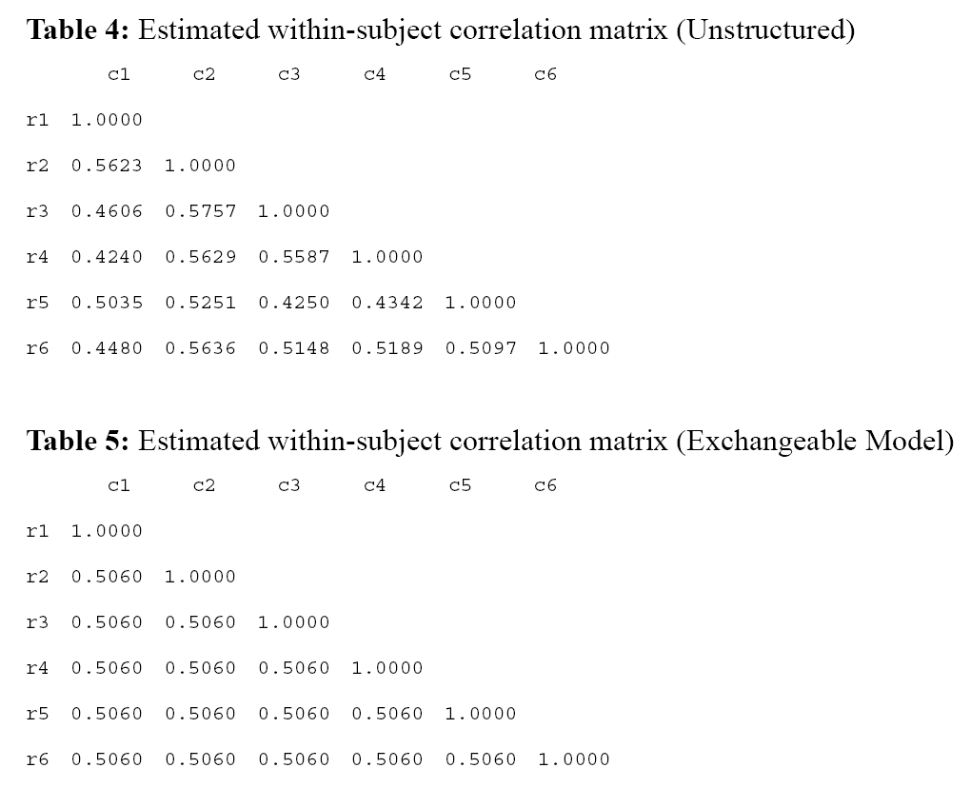

OUTPUT FOR 2

